**R Programing**

**Practical 1**

**Basics Of R Studio**

# Get current working Directory

getwd()

#set current working directory using command

setwd("D:\\Praful Karan\\R Programing")

#set current working directory using session-> set working dir menu option

# trick for using multiline comment

#R programing doesn't support multiline comment

if(FALSE)

{

"this is multiline comment"

"i hope this will work"

}

# end of multiline comment

#R is case sensetive

# R is loosely type language

# To load Package

library(graphicalExtremes)

#To Install Package

install.packages()

**Practical 2**

**Data Types in R Programing**

# uses of (var_name <- value) and (value -> var_name) operator for assigning

# numeric data type

x = 10

class(x)

typeof(x)

#Integer data type requires 'L'

x = 10L

class(x)

typeof(x)

#double

x<- 10.5

class(x)

typeof(x)

#Character

x="praful"

class(x)

typeof(x)

#LOGICAL DATA TYPE TRUE OR FALSE

x=TRUE

class(x)

typeof(x)

# COMPLEX DATA TYPE

x =10 + 0i

y =5 + 0i

z =x + y

z

class(z)

typeof(z)

# Raw Type

x = as.raw("Praful Karan")

x

class(x)

typeof(x)

**OUTPUT:-**

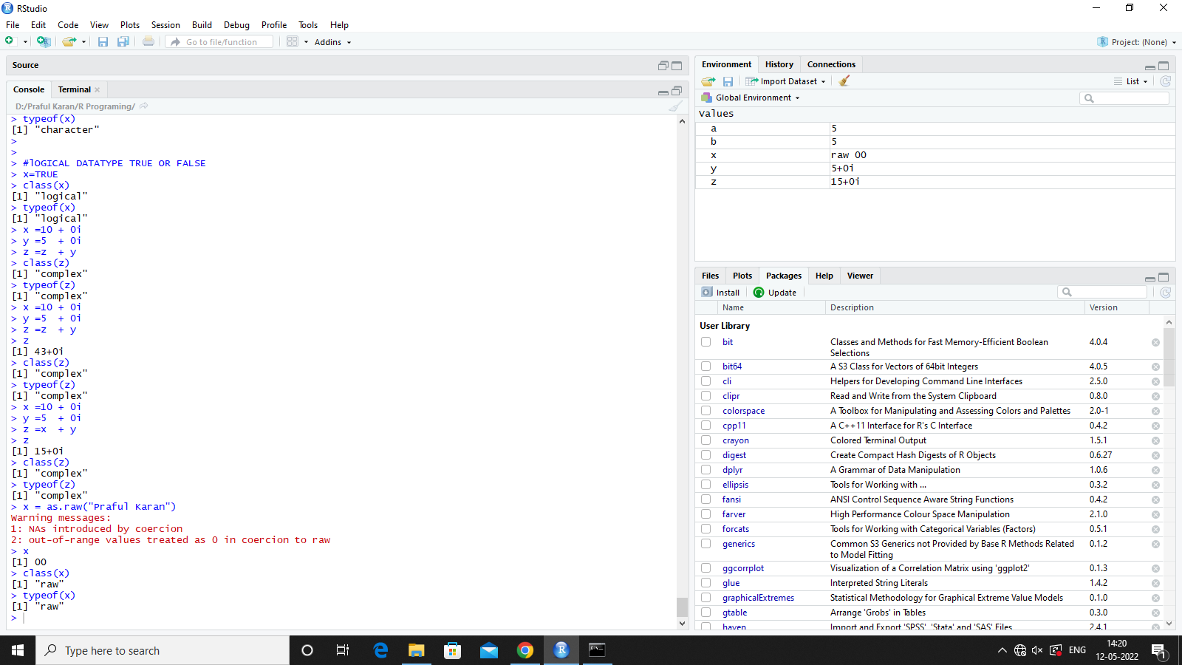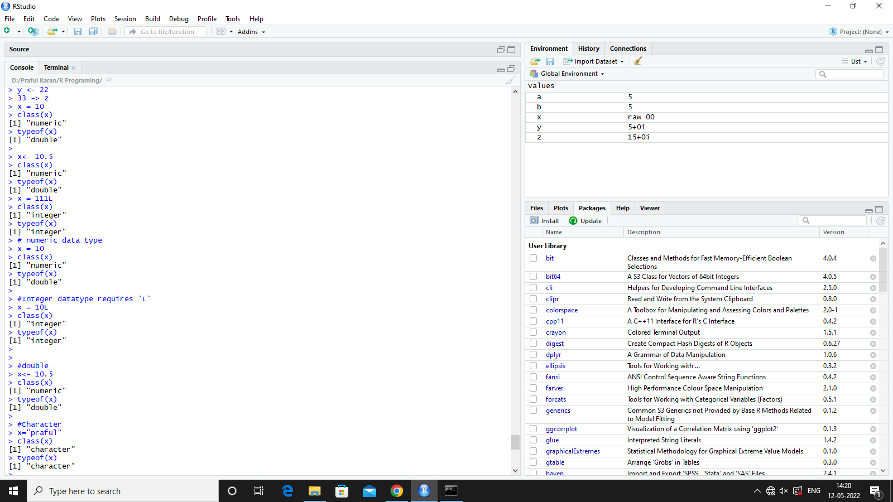

**Practical 3**

**Different way to Get Output**

name = "Praful Karan"

# output functions

print(name)

cat(name)

cat("Hello ",name)

paste(name)

paste("Hello",name)

paste0(name)

paste0("Hello",name)

name=1234

sprintf("name is %d",name)

print(paste("welcome to R Programing", name))

**OUTPUT :-**

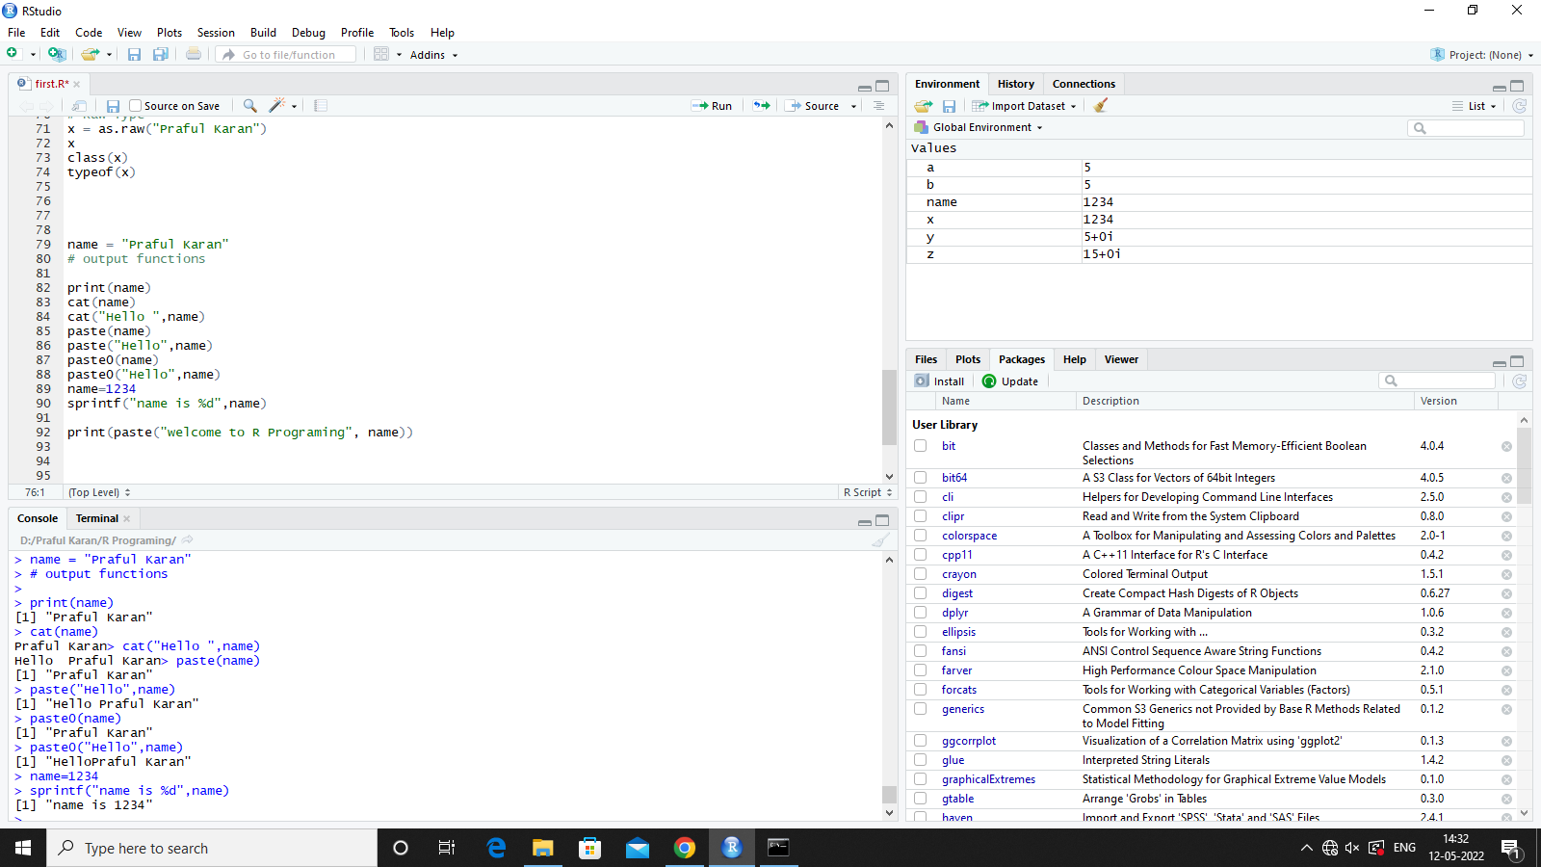

**Practical 4**

**How to get user input on Console**

1. **ReadLine**

# accepting User input from console

#{} = anonymous function

{

email = readline(prompt = "Enter Your Name: ");

password = readline(prompt = "enter your password: ");

print(paste("Welcome, ",email,password))

}

**OUTPUT:-**

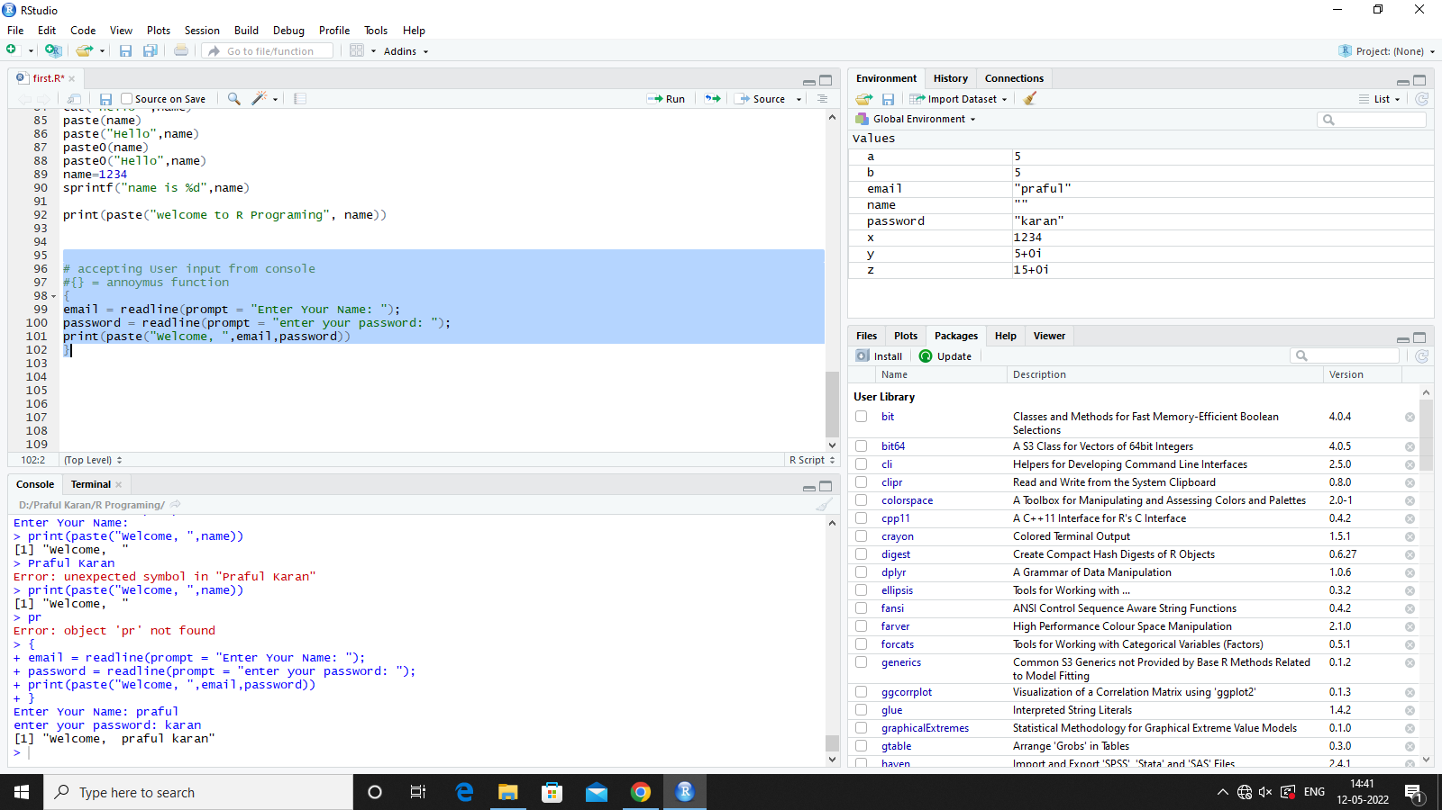

**2) Scan**

# Scan read as long as u want

name = scan(what="")

name = scan(what=double())

**OUTPUT:-**

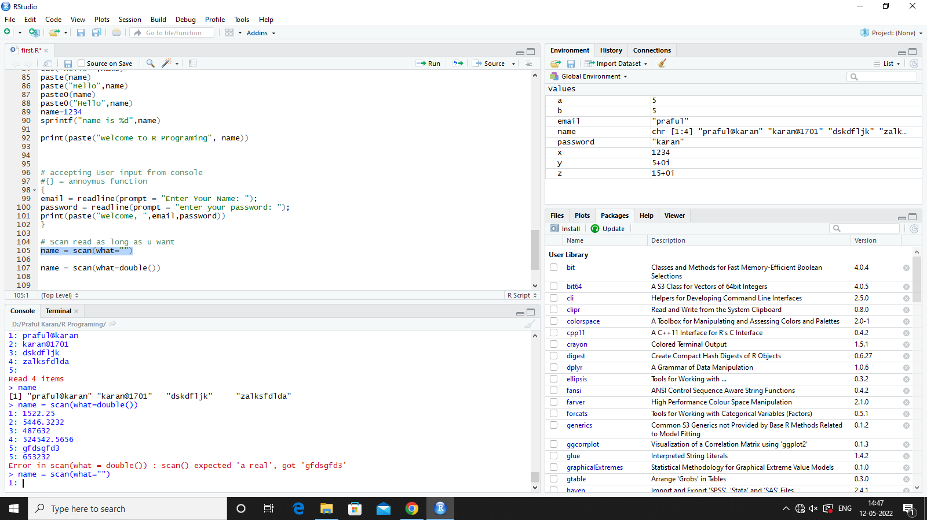

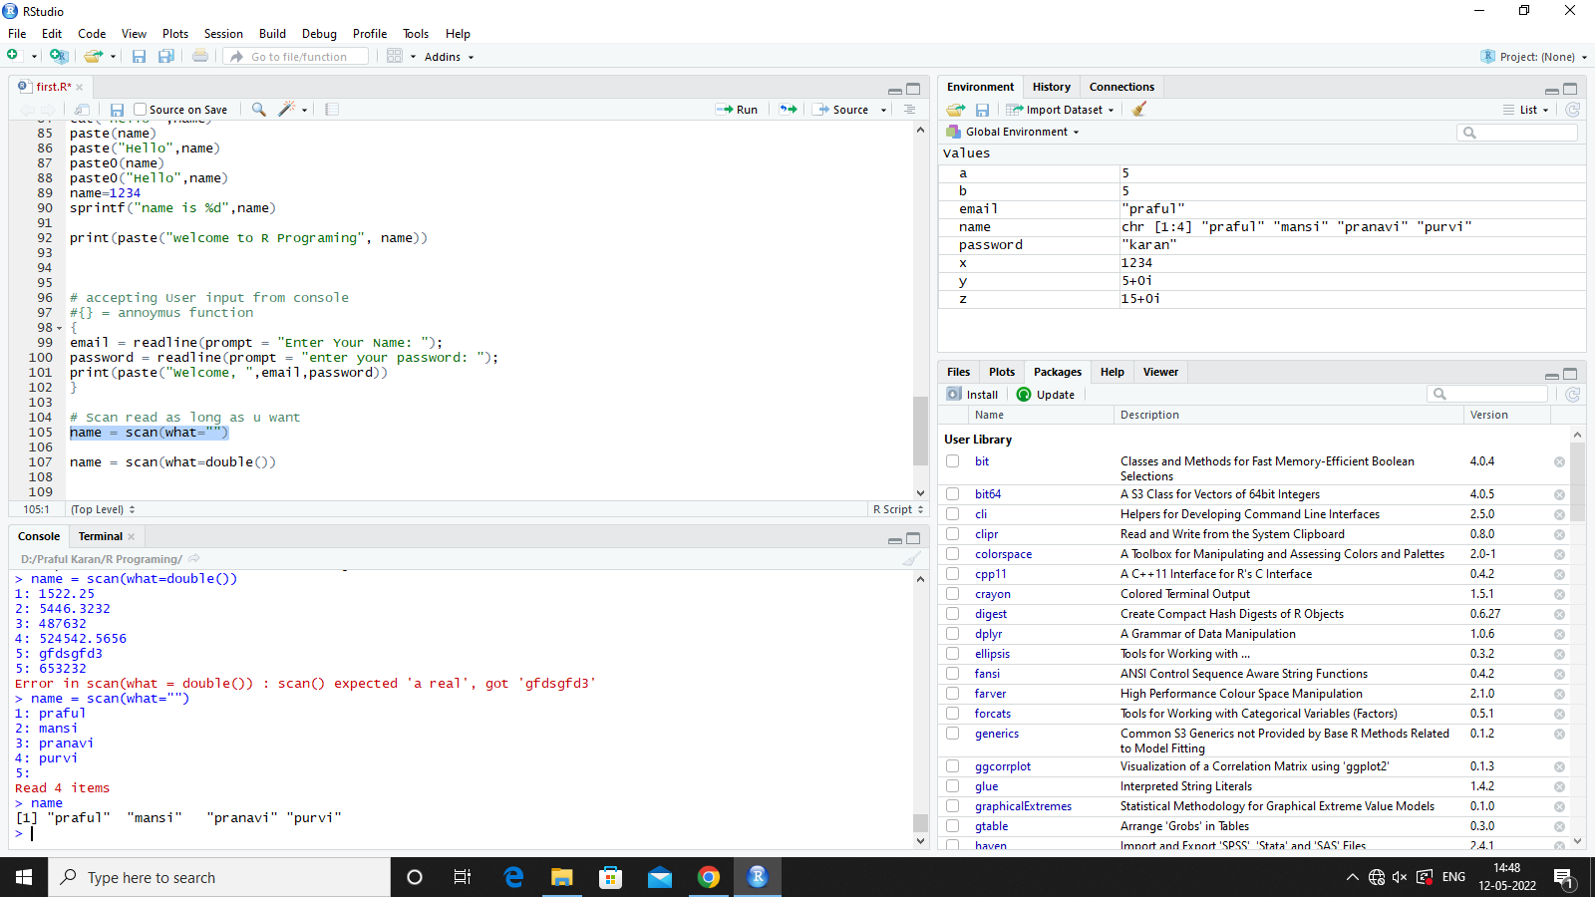

**Practical 5**

**Function in R Programing**

# function in R

# built in and user defined

# user defined functions

**1) function without parameter**

normal<- function(){

print(paste("f function is called.."))

}

normal

hello<- function()

{

print("Hello World")

}

hello()

**2)Function with Parameter**

parameterized<- function(a,b ){

print(paste("user passed a: ",a,"b: ",b))

return (a+b);

}

x = parameterized(5,6)

x

**OUTPUT:-**

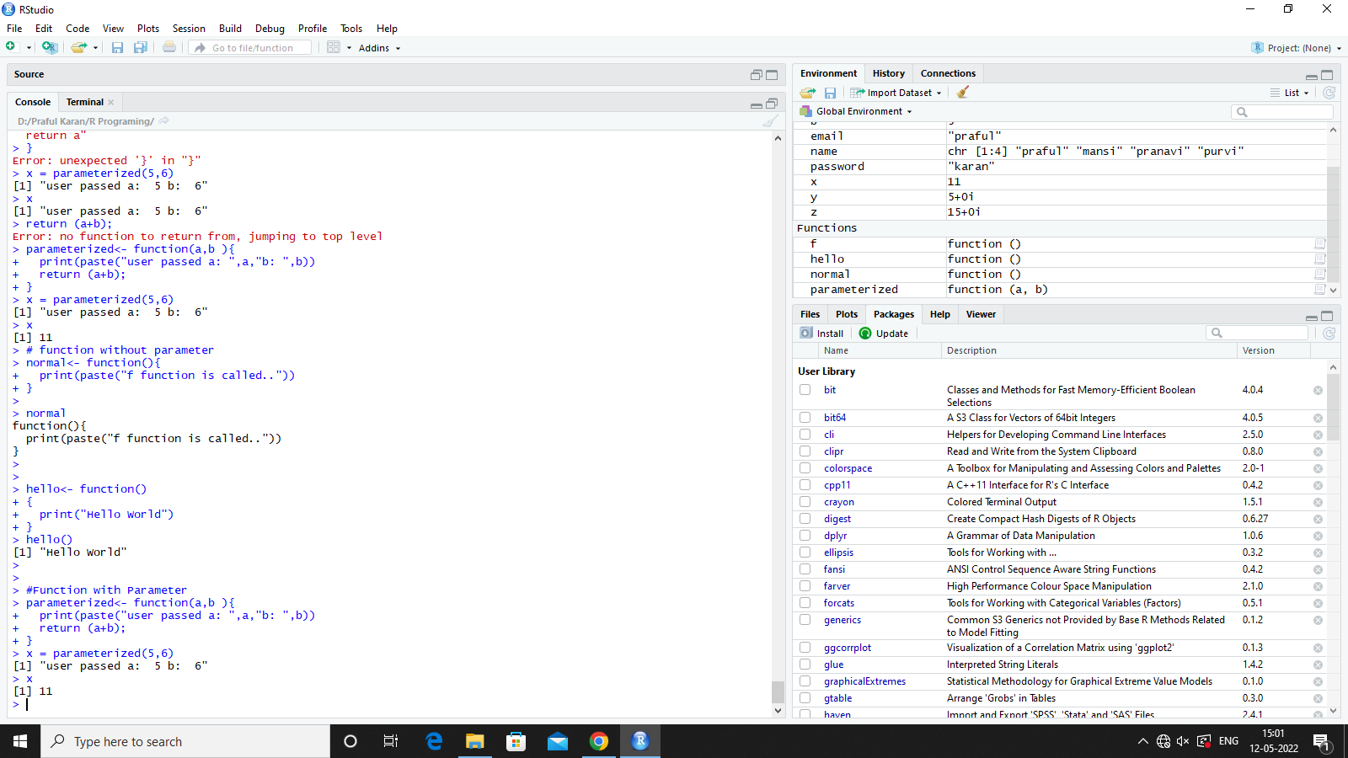

**3)Default Parameter**

# Default Parameter

parameterized<- function(a,b,c=45 ){

print(paste("user passed a: ",a,"b: ",b,"c: ",c))

return (a+b+c);

}

x = parameterized(5,6)

X

**OUTPUT:-**

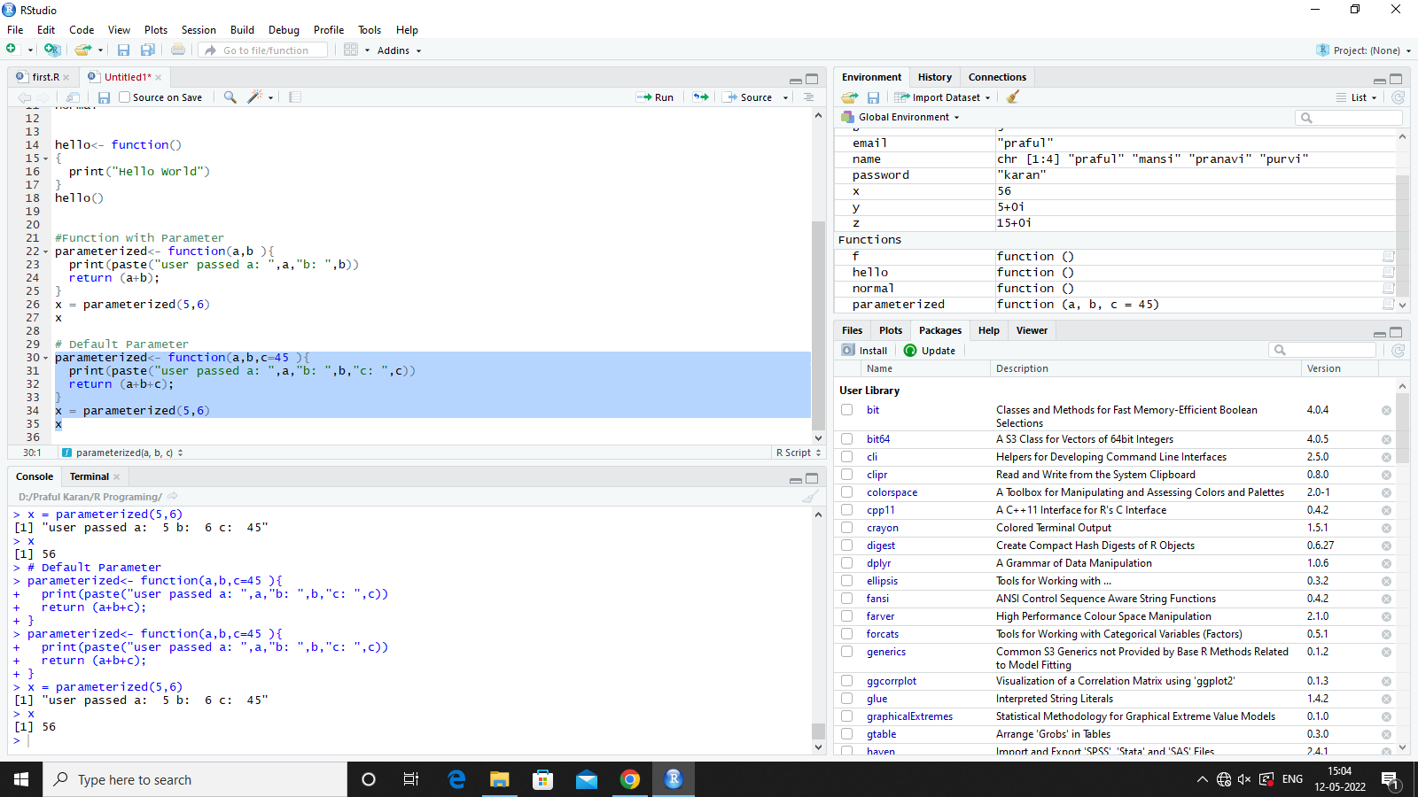

**Practical 6**

**Data Structures In R**

# Data Structure In R

# 1. Vectors

# 2. Lists

# 3. Arrays

# 4. Matrix

# 5. Data Frames

# 1. R is obsessed by the Vectors

# 1.1 atomic Vectors

# 1.2 created with seq()

# Atomic Vectors

vectorN = c(1,2,3,4,5)

vectorN

class(vectorN)

vectorC = c("Hello","Welcome to atomic Vectors","TC")

vectorC

class(vectorC)

vectorL = c(TRUE,FALSE,TRUE,FALSE,TRUE,TRUE,FALSE)

vectorL

class(vectorL)

vectorAA = c("Praful"<=13,"karan"<=17,"KJSIM"<=12033)

vectorAA

class(vectorAA)

**OUTPUT:-**

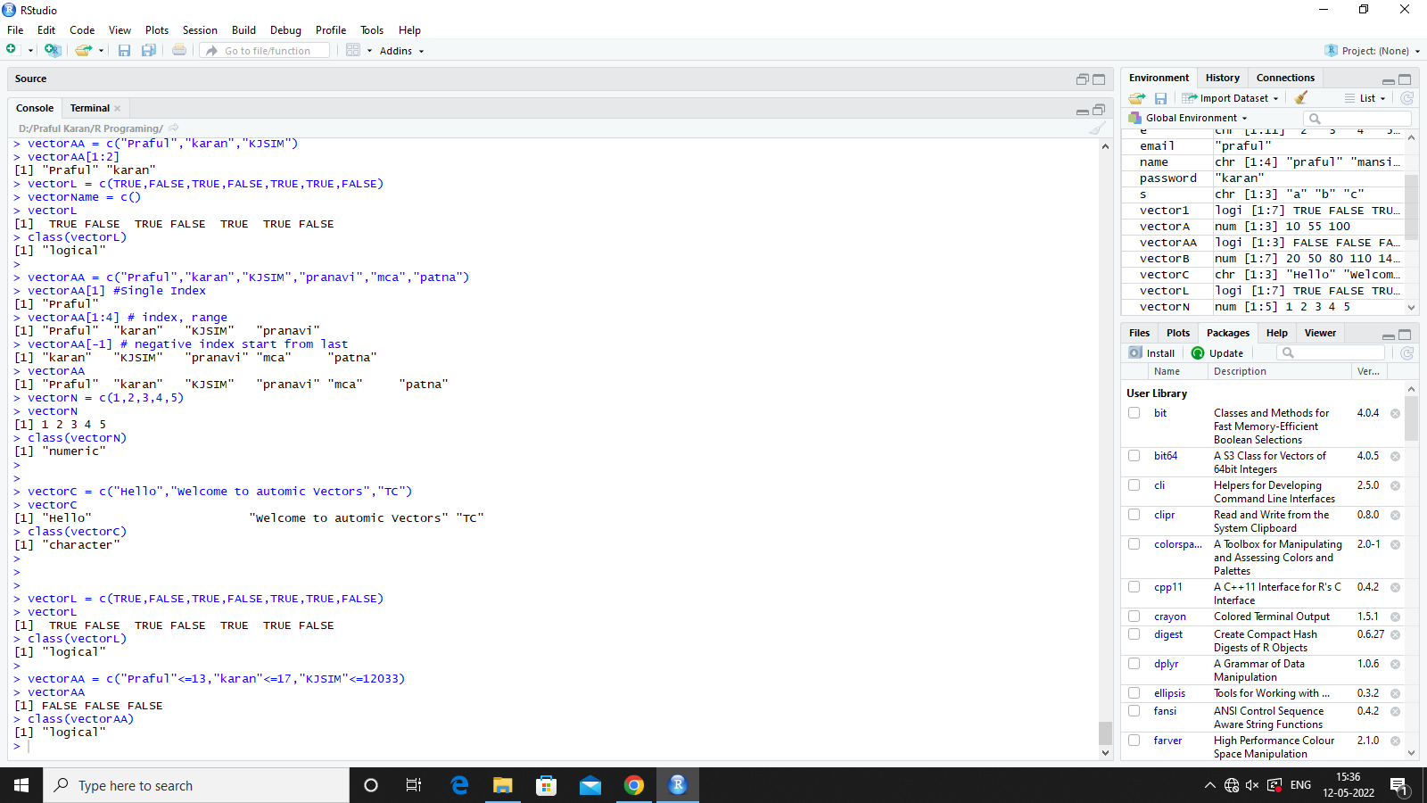

vectorA = seq(1:10) # print 1,2,3,4,5,6,7,8,9,10

vectorA

vectorA = seq(1,10,by=2)

vectorA

vectorA = seq(10,100,by=20) #skips 20 each times like 10-30-50

vectorA

vectorA = seq(10,100,length.out = 3)# randomly choose 3 number

vectorA

vectorA = seq(10,100,length.out = 3)

vectorB = seq(20,200,length.out = 7)

vectorC = vectorA + vectorB # we can perform arithmetic operation on vectors

vectorC

**OUTPUT:-**

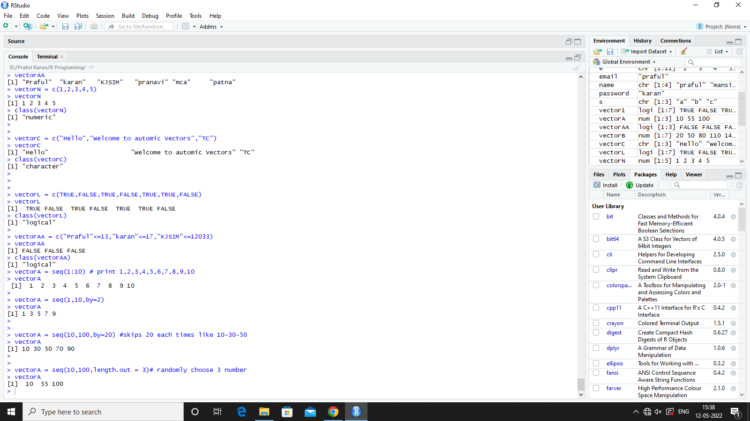

a = c(2,3,4,5)

b = c(5,7,6,4)

d = a+b

e=c(a,b) # create a new vectors

e

s=c("a","b","c")

e=c(a,b,s)

e

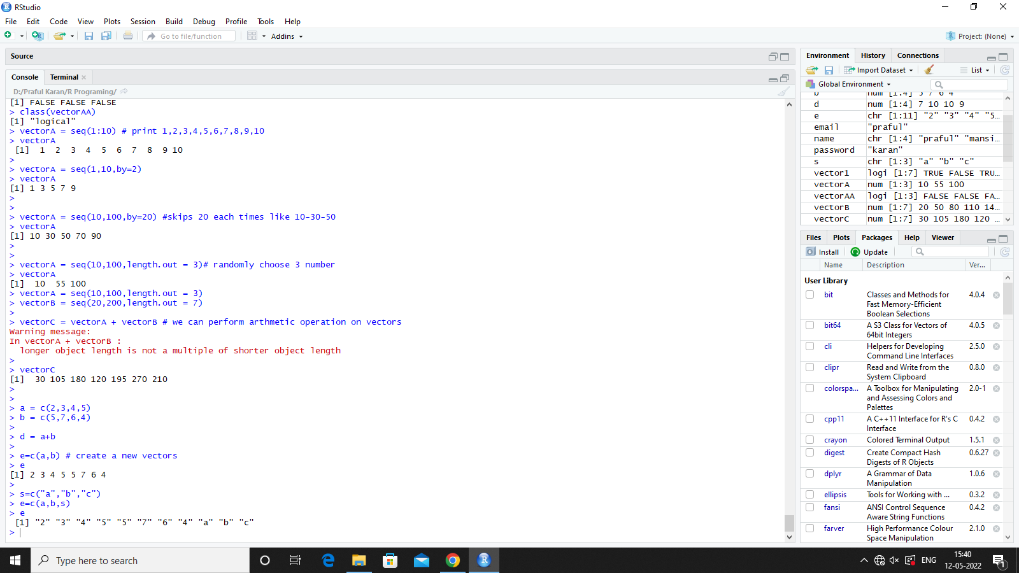

# when we combine logical with range only the true value prints rest all are ignored

vectorL = c(TRUE,FALSE,TRUE,FALSE,TRUE,TRUE,FALSE)

vectorName = c()

vectorL

vectorAA = c("Praful","karan","KJSIM","pranavi","mca","patna")

vectorAA[1] #Single Index

vectorAA[1:4] # index, range

vectorAA[-1] # negative index start from last

vectorAA

**OUTPUT :-**

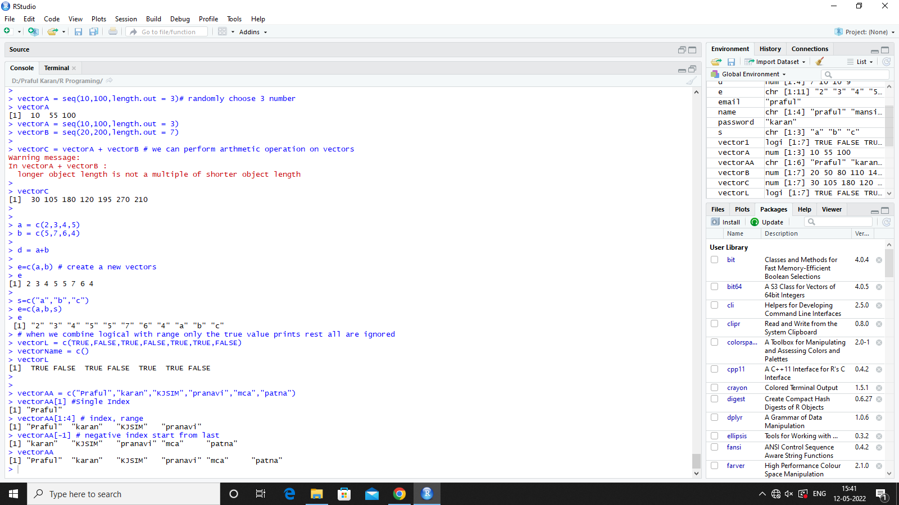

**Practical 7**

**Lists**

list1 = list(c(1,2,3),"MCA",c("abc","def","xyz"),1,2,3)

list1

x = c(11,22,33)

y= c("abcd","def","xyz","amnc")

list1 = list(x,y,c(11.23,33.4,56.4))

x1 = list(101,"Praful","MCA",c(22,1000000,525))

x2 = list(102,"Karan","MBA",c(45,"mt2",785))

# Passing name to the list index elements

name(x2)=c("Roll No","Name","Course","Mark")

x2

list2 = list(x1,x2)

list2

list1[[4]] = c(2,4,5,6,7)# appending value at the end of list using index

list1[[4]] = NULL #deleting list elements at the end using index

list1[[1]] #returning values in vectors

list1[1] #returning first vector as list item

# Iterating through list using loop

for(i in list1)

print(i)

# Iterating through vector using loop

y= c("abcd","def","xyz","amnc")

for (i in y)

print(i)

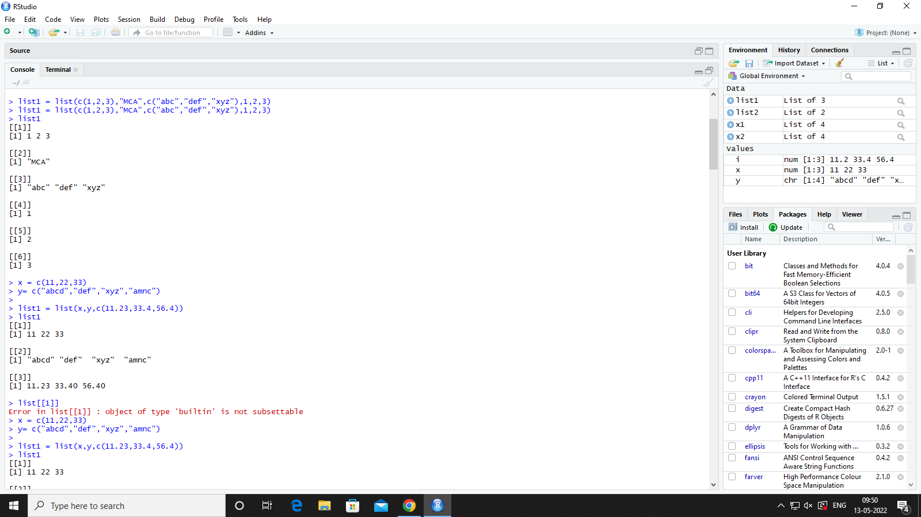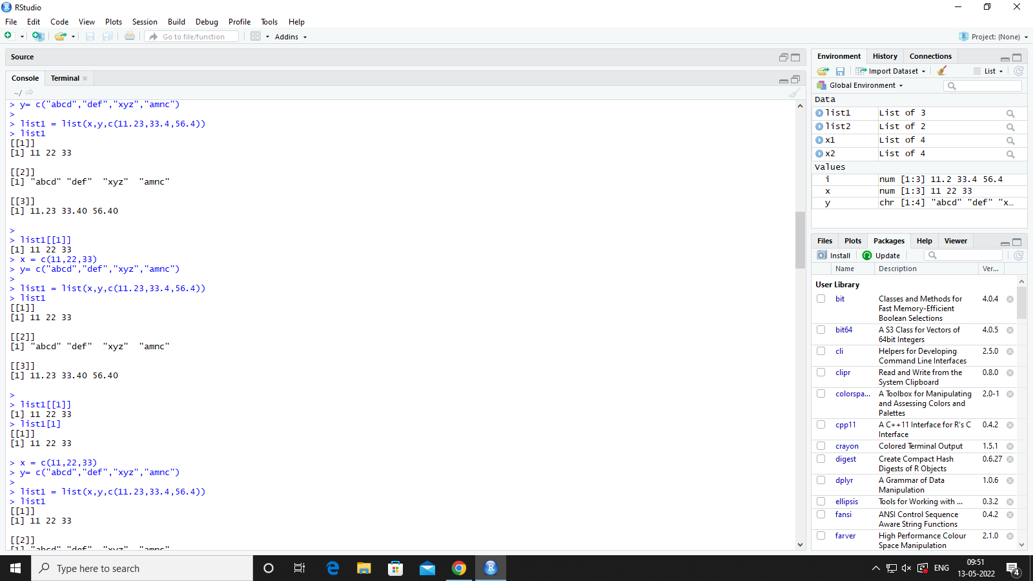

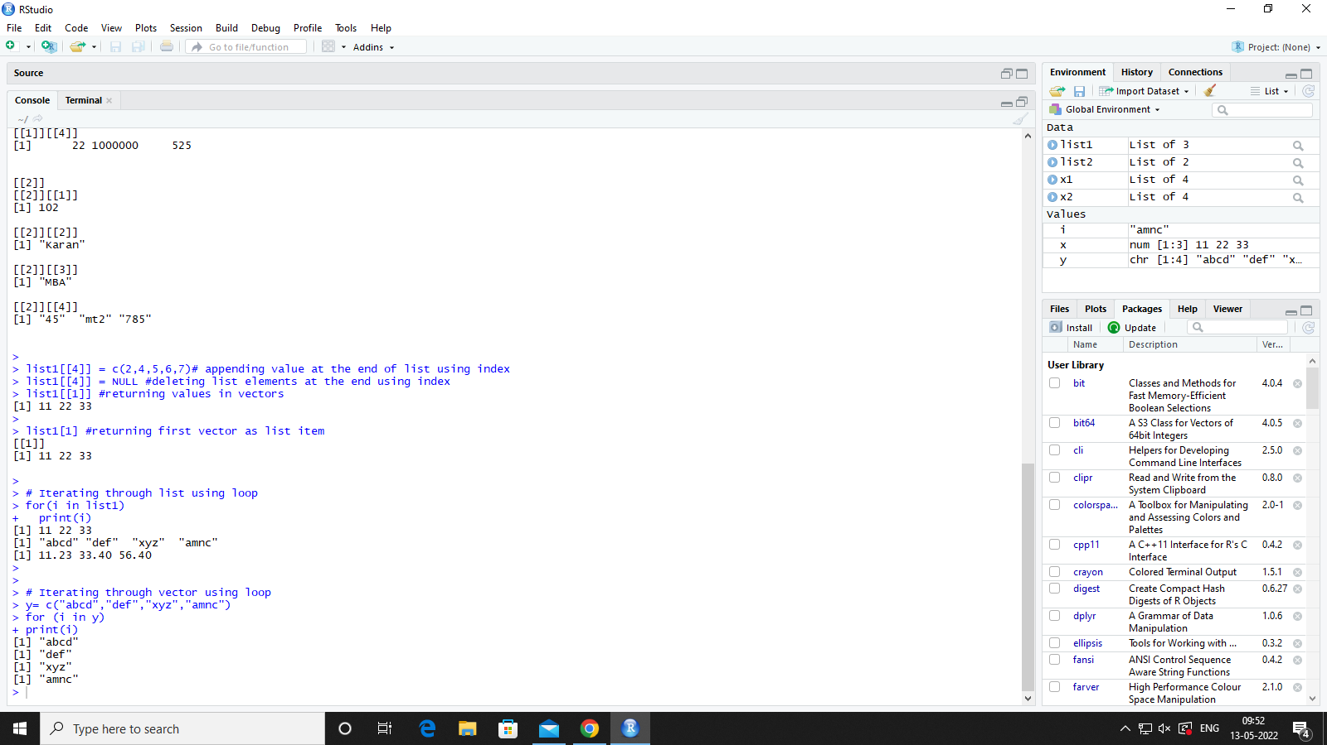

**Practical 8**

**Array**

#Array

# Array(data,dim=rows,cols,no of matrix)

array1 = array(c(11,22,33,44),dim=c(2,2))

array1 = array(c(11,22,33,44,55,66,77),dim=c(3,3,2),dimnames = list(row_names,col_names,matrix_name))

array1

row_names=(c("student1","student2","student3"))

col_names=(c("mk1","mk2","mk3"))

matrix_name=c("div1","div2")

for(i in array1)

print(i)

array1

array1[,,1] #matrix1

array1[1,2,1] # first row, second colon , first matrix

array2 = apply(array1[,,1],1,(sum)) #apply(data,1-row,2-col,sum)

array2

mysum <- function(element)

{

element = element+5

}

array2 = apply(array1[,,1],1,mysum) #apply(data,1-row,2-col,sum)

array2

array2 = apply(array1[,,1],2,mysum) #apply(data,1-row,2-col,sum)

array2

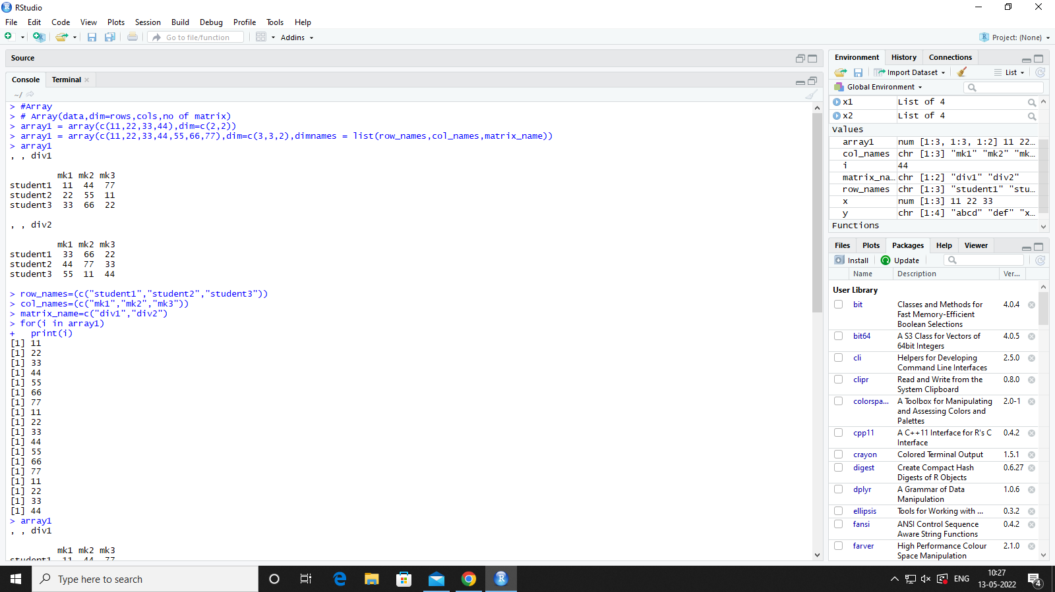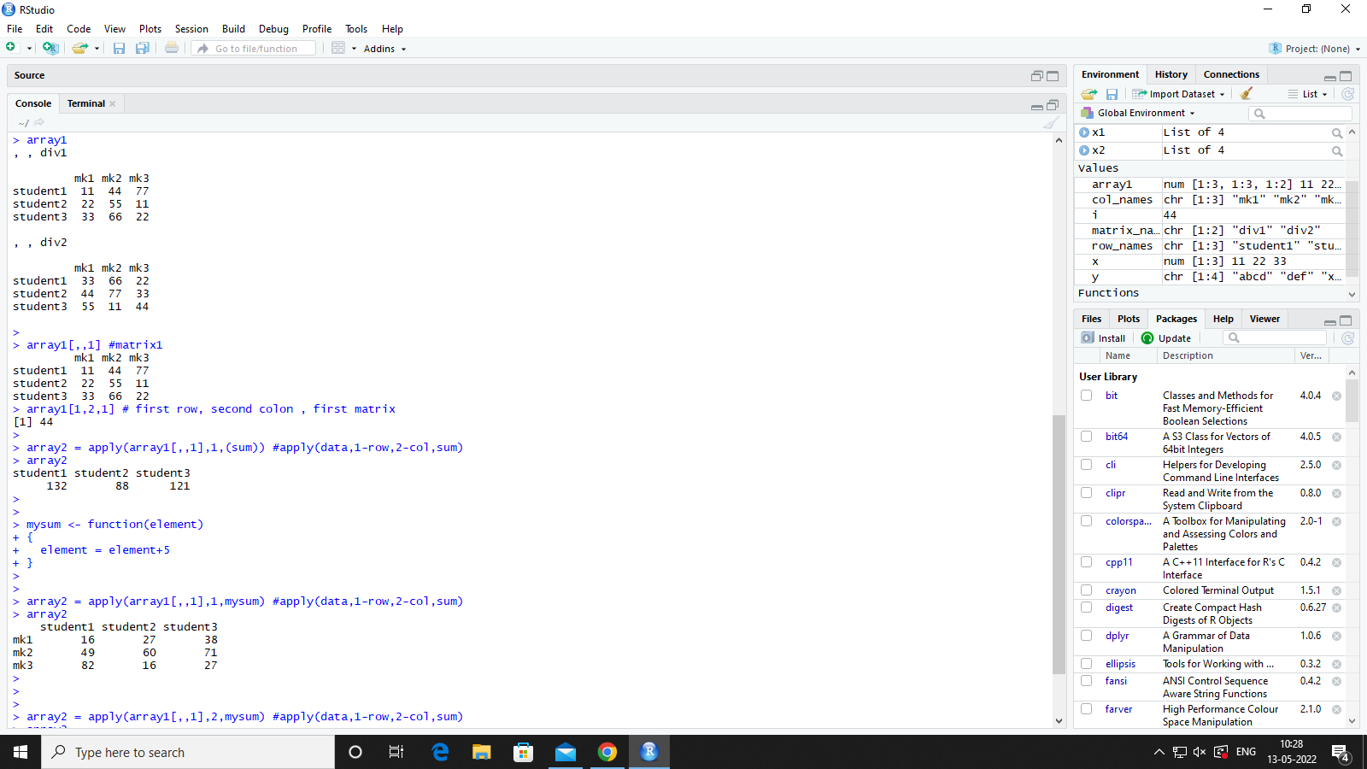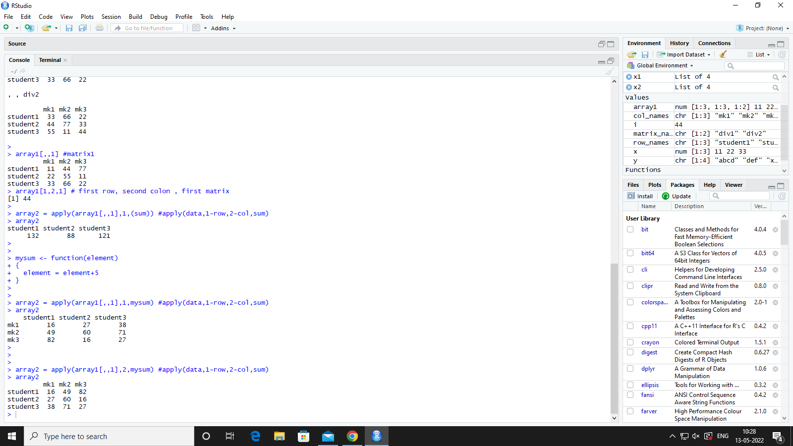

**Practical 8**

**Factors**

# Factors

courses = c("MCA","MBA","BBA","CA","DCA","MIM","MAX")

class(courses)

courses = factor(courses,levels = c("MCA","MBA","MIM"))

is.factor(courses)

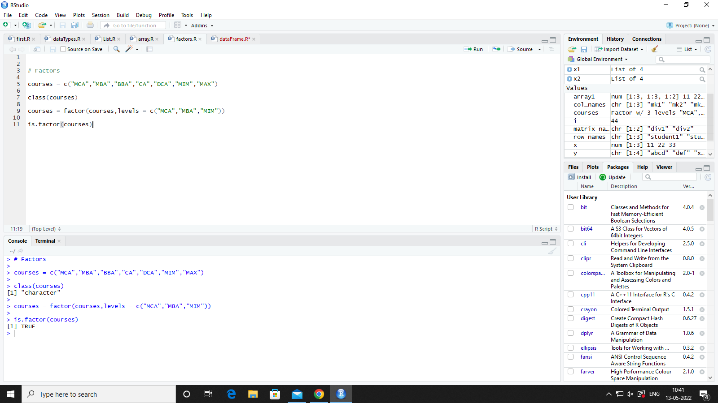

**Practical 9**

**DataFrame**

# data Frame In R

# Col name are compulsory

# row value should be null

empdata = data.frame(

empid = c(101,102,103,104,105),

empname = c("praful","karan","rahul","aman","rohan"),

empdpt = c("java",".net","php","java",".net"),

empcity = c("patna","mumbai","kolkata","delhi","nalanda"),

empsal = c(20000,25000,45000,65230,78550),

empdoj = c("2012-02-14","2015-04-12","2012-02-14","2015-04-12","2004-12-31"), #yyyy-mm-dd

stringsAsFactors = FALSE

)

empdata

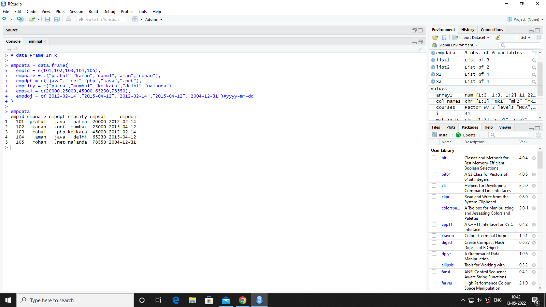

**# checking weather empdata is dataframe**

is.data.frame(empdata)

**# structure of data frame**

str(empdata)

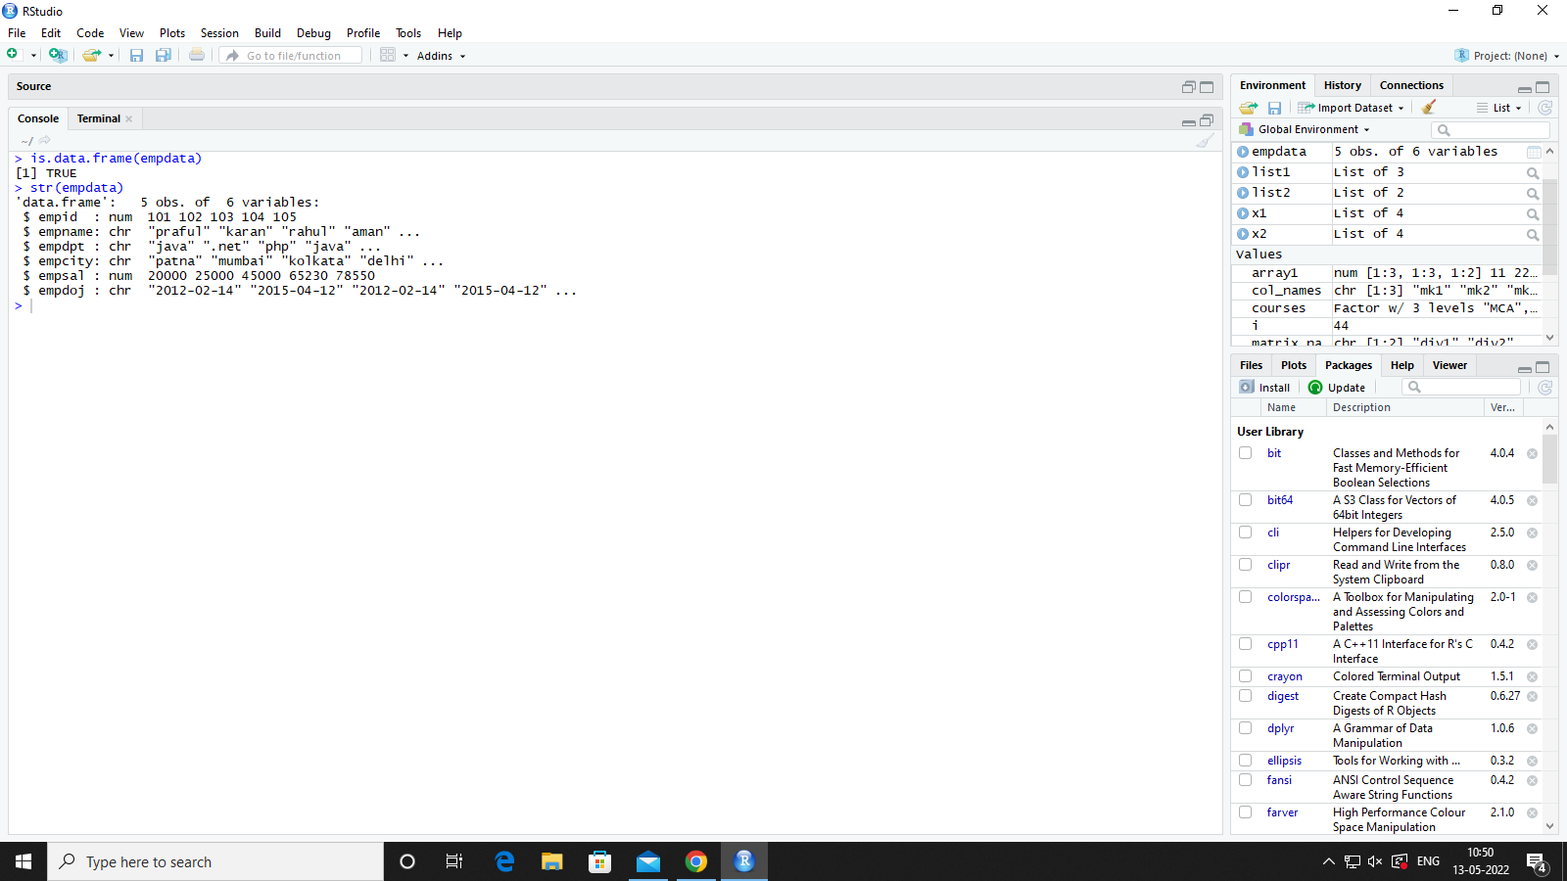

**SUMMARY**

#Summary

summary(empdata)

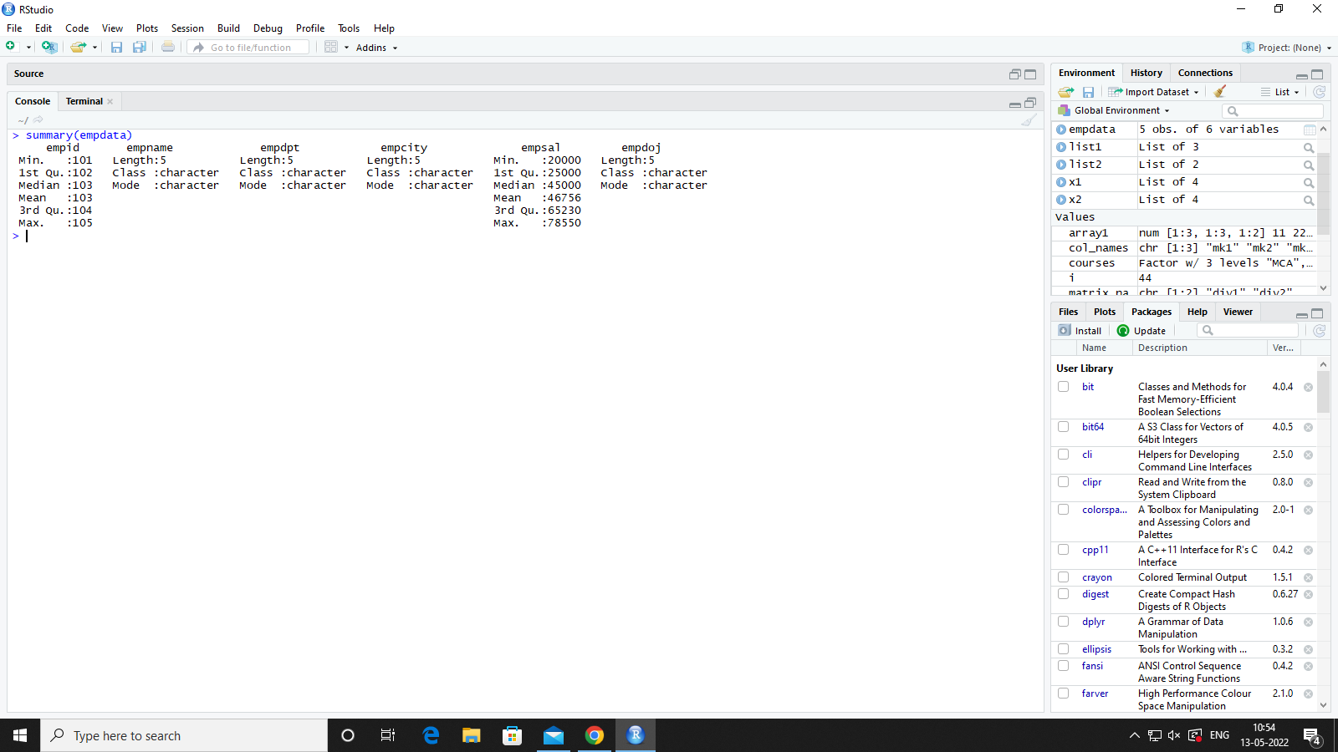

**#$ is used for list in that column**

**#accessing data frame**

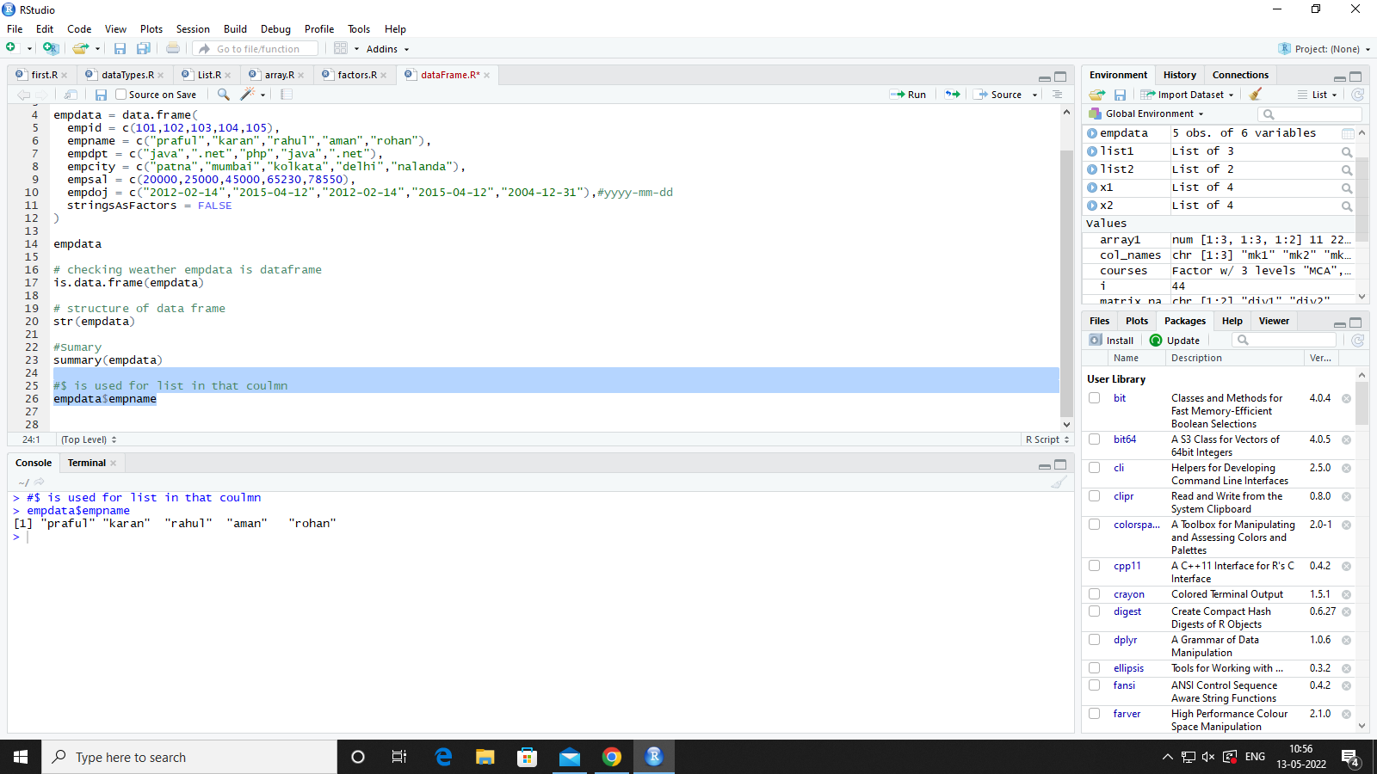

**#we can store large data frame in small variable**

df = data.frame(empdata$empid,empdata$empname)

df

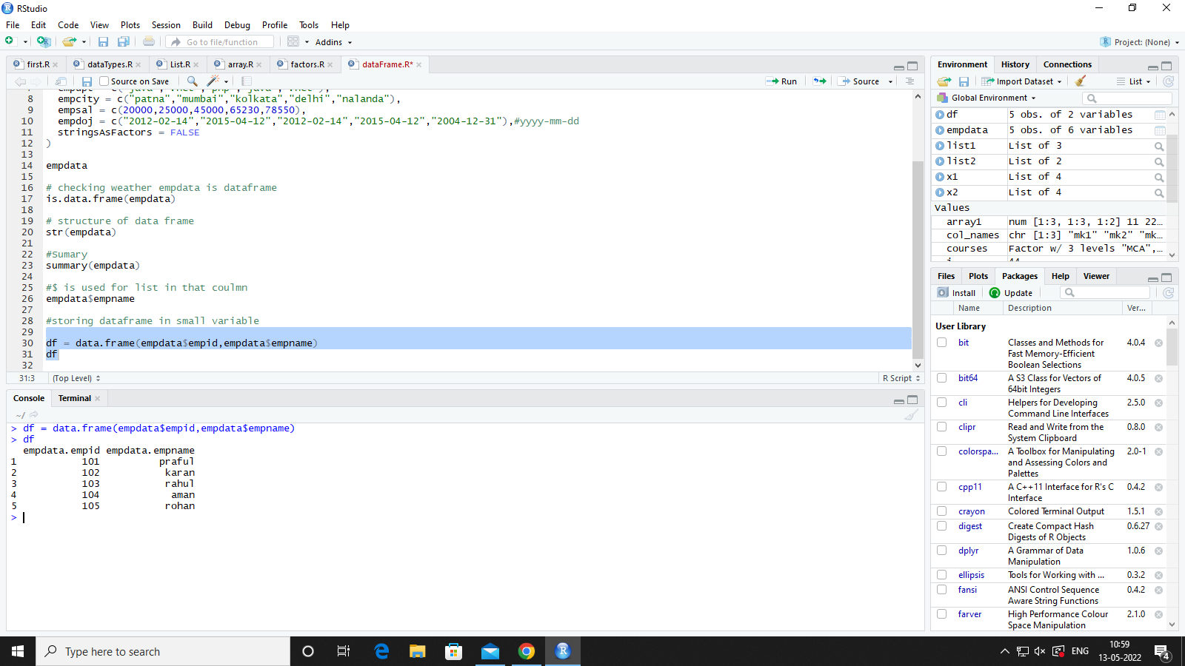

**Binding Two DataSets**

empdata = data.frame(

empid = c(101,102,103,104,105),

empname = c("praful","karan","rahul","aman","rohan"),

empdpt = c("java",".net","php","java",".net"),

empcity = c("patna","mumbai","kolkata","delhi","nalanda"),

empsal = c(20000,25000,45000,65230,78550),

empdoj = c("2012-02-14","2015-04-12","2012-02-14","2015-04-12","2004-12-31"),#yyyy-mm-dd

stringsAsFactors = FALSE

)

empdata

empdata1 = data.frame(

empid = c(201,202,203,204,205),

empname = c("mirzapur","abhi","rohan","mohan","manjit"),

empdpt = c("c","c++","html","python","dbms"),

empcity = c("punjab","Kerala","bangladesh","usa","aust"),

empsal = c(8000,2000,5000,6230,8550),

empdoj = c("2010-12-03","2008-06-25","2012-02-14","2015-04-12","2004-12-31"),#yyyy-mm-dd

stringsAsFactors = FALSE

)

empdata

**#output of rbind() and cbind() will not be accessible if not stored**

employeeData = rbind(empdata,empdata1)

employeeData

**OUTPUT:-**

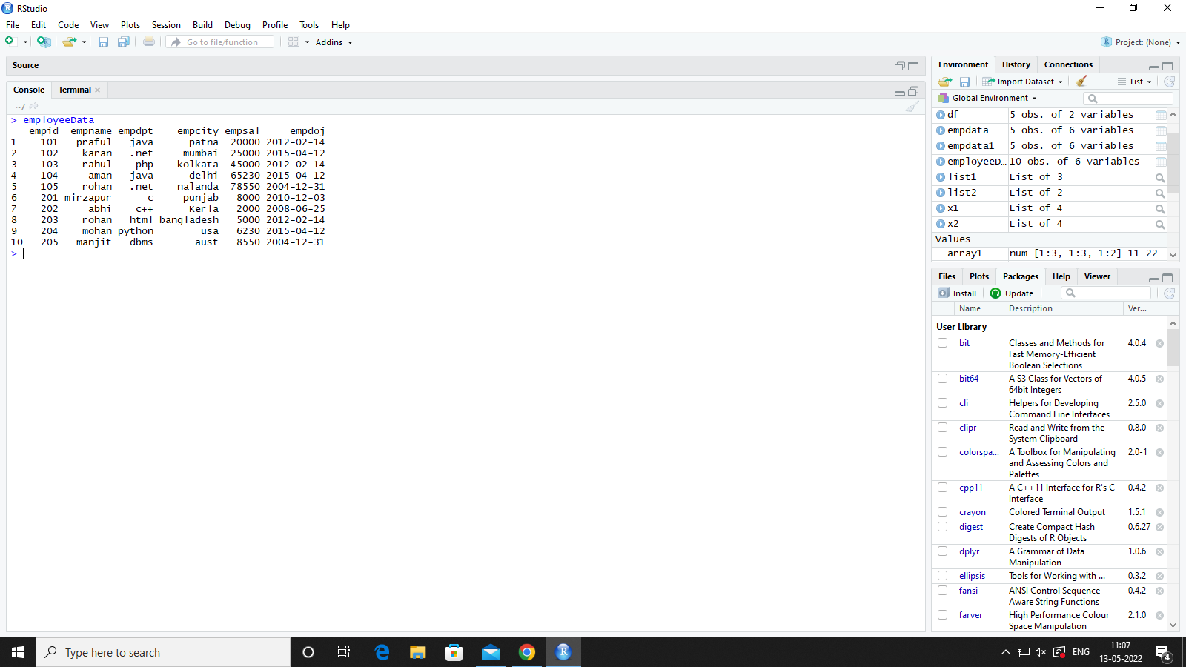

**To insert Single Record**

rec = list(301,"Manshi","MCA","Nashik",12500,"1997-12-28")

employeeData = rbind(rec,employeeData)

employeeData

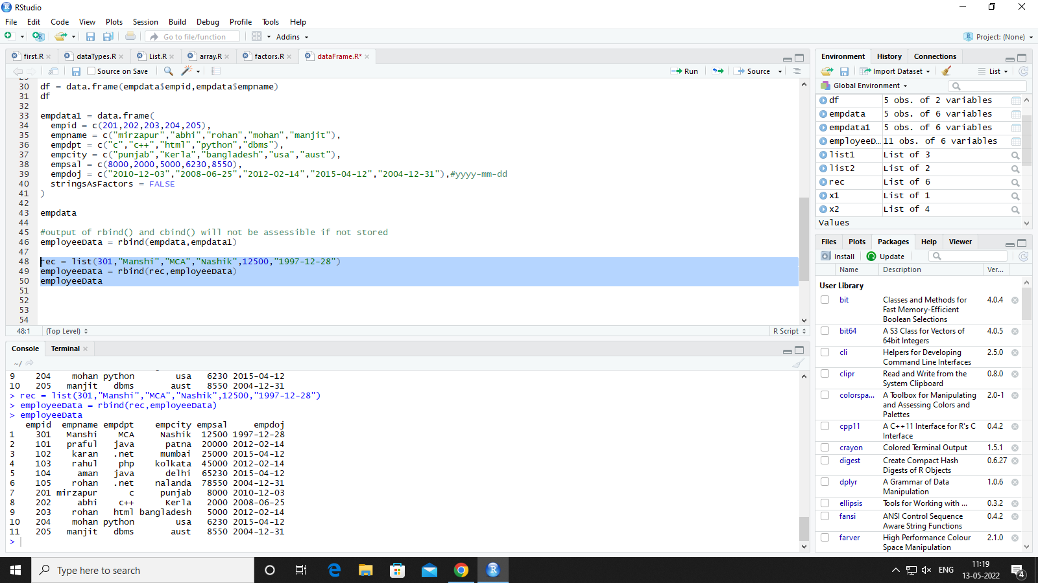

**To Insert a New Column**

#To Add New Column we use Cbind()

gender = c("F","M","F","F","M","F","F","M","F","F","M")

employeeData = cbind(employeeData,gender)

employeeData

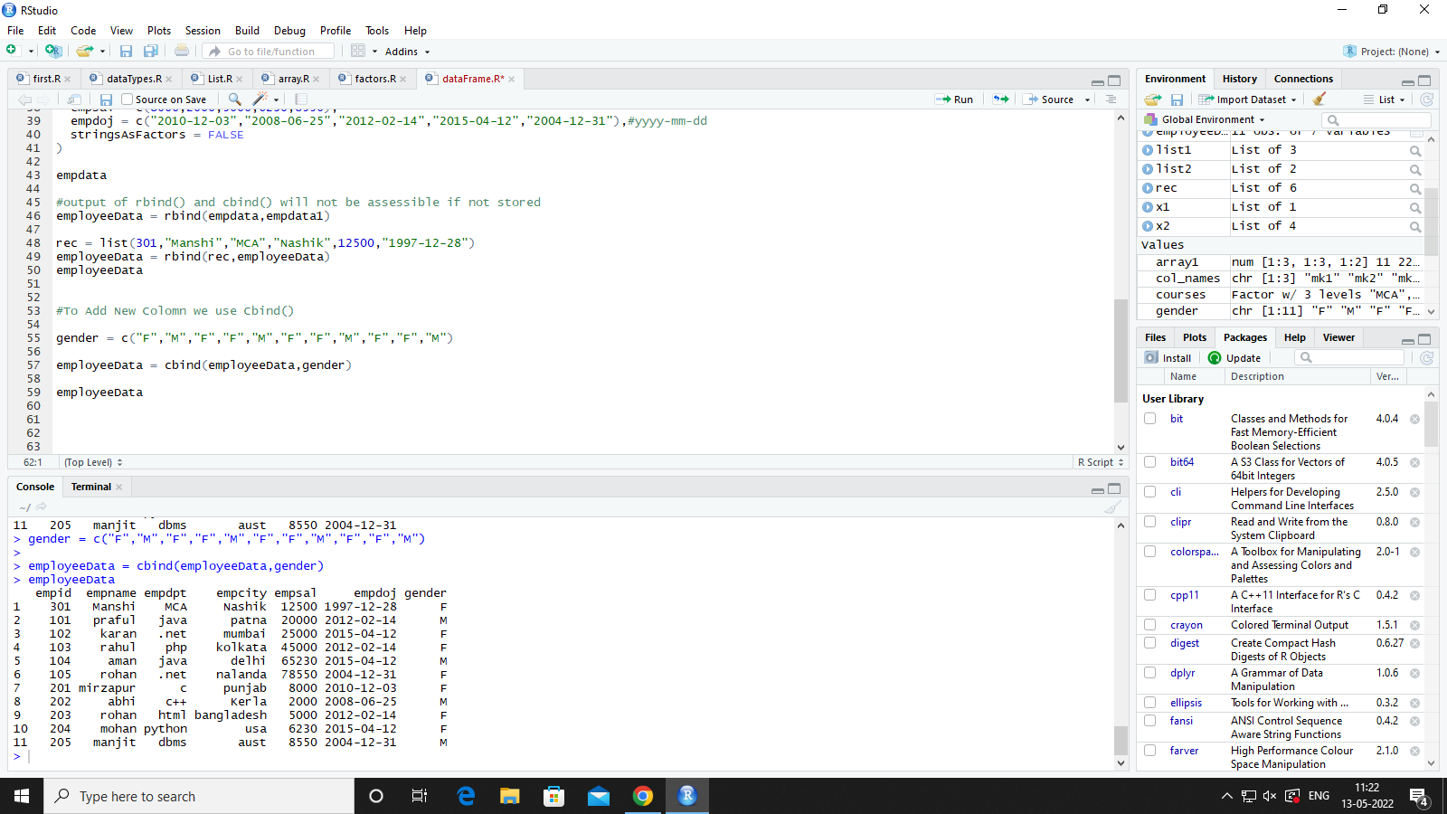

**Practical 10**

**DataFrame(Subset)**

# SUBSET

# use of subset function for dataframe record access/filters

subset(employeeData,empcity=="mumbai")

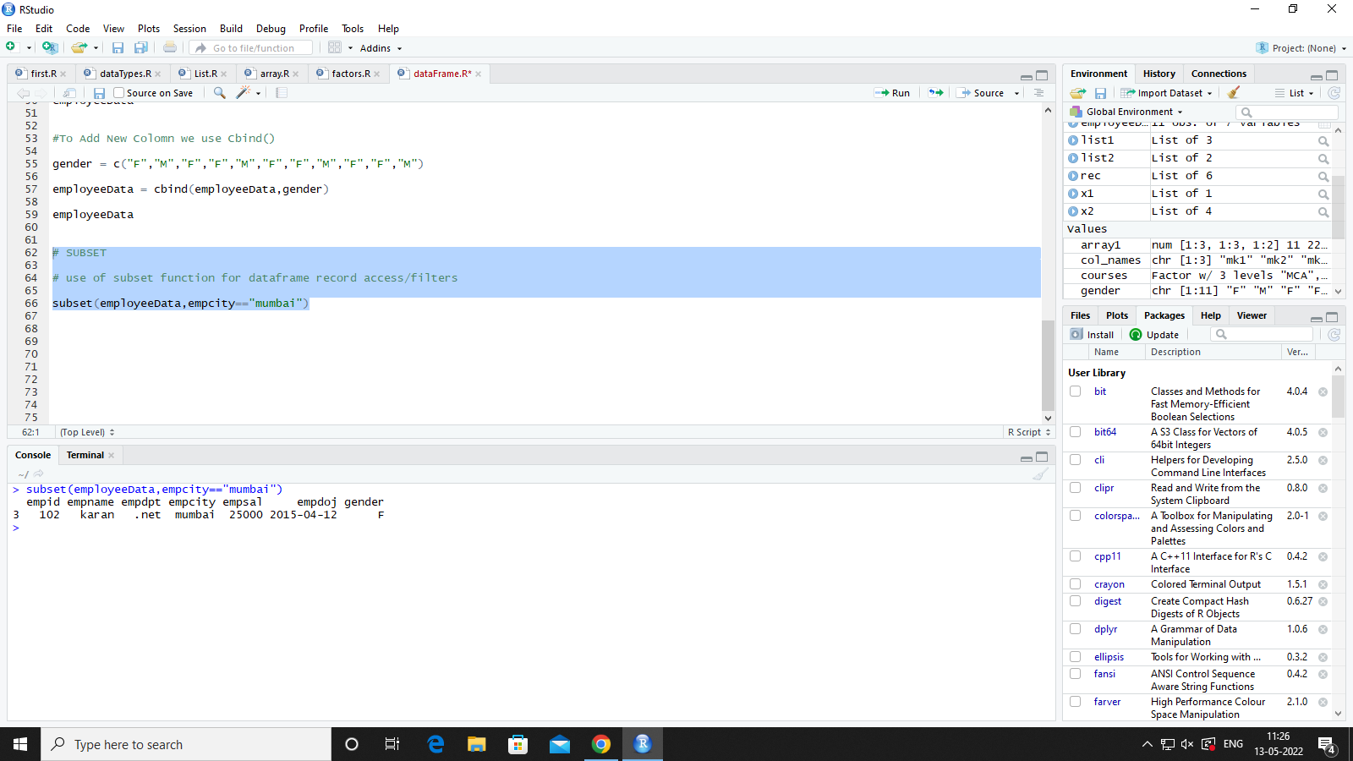

**# Check record for max sal in dataframe**

subset(employeeData,empsal==max(employeeData$empsal))

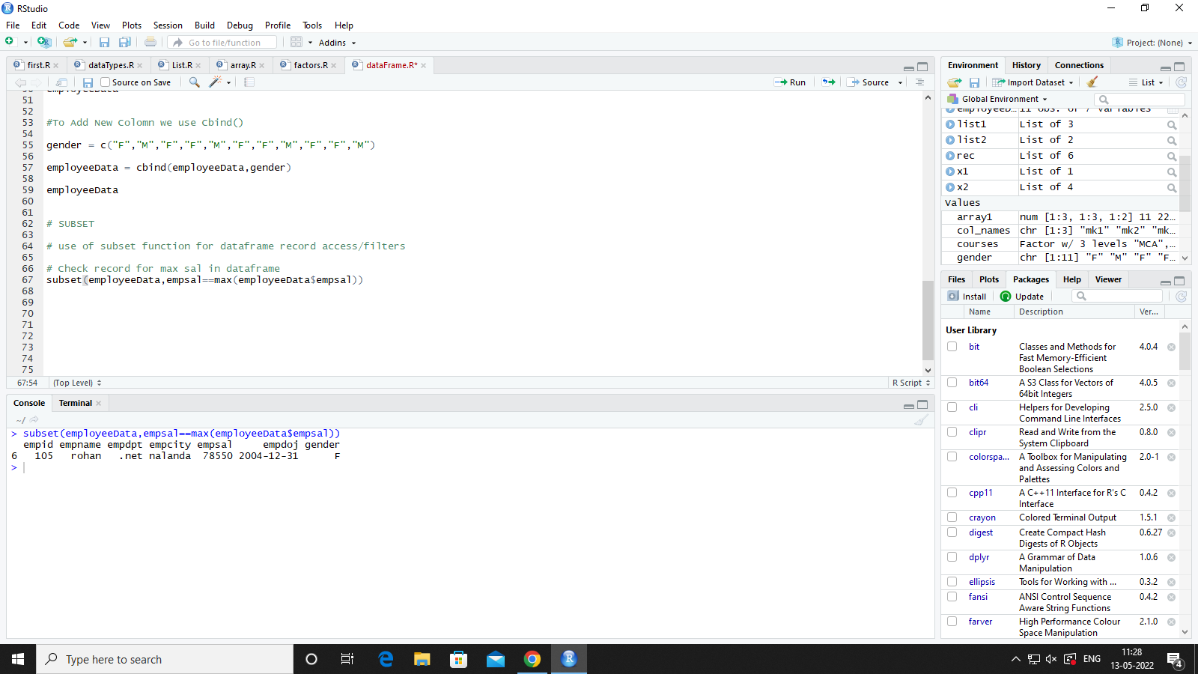

**# check employee joined after 2012**

subset(employeeData,as.Date(empdoj)>as.Date("2012-01-01"))

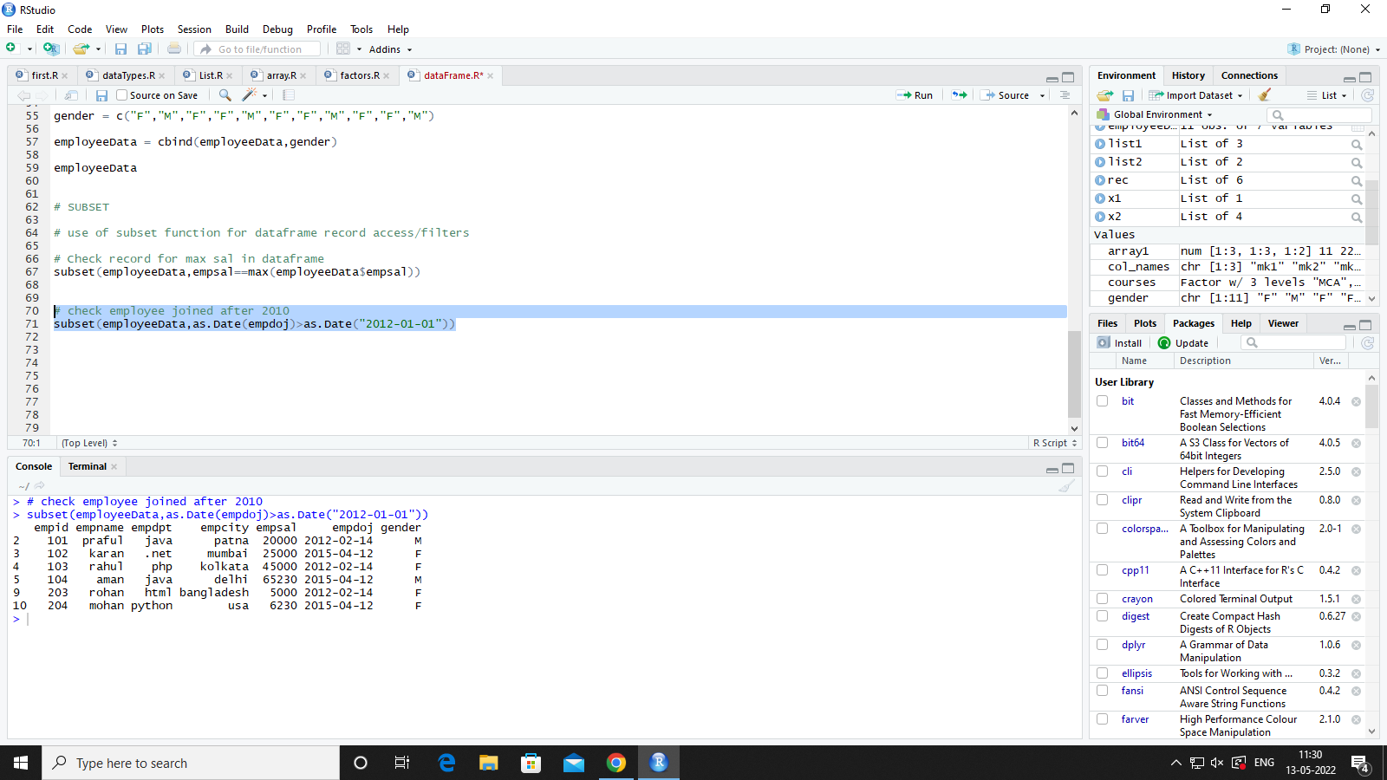

**#Fetch the records of salary between 5k to 15k**

subset(employeeData,empsal>5000 & empsal <15000)

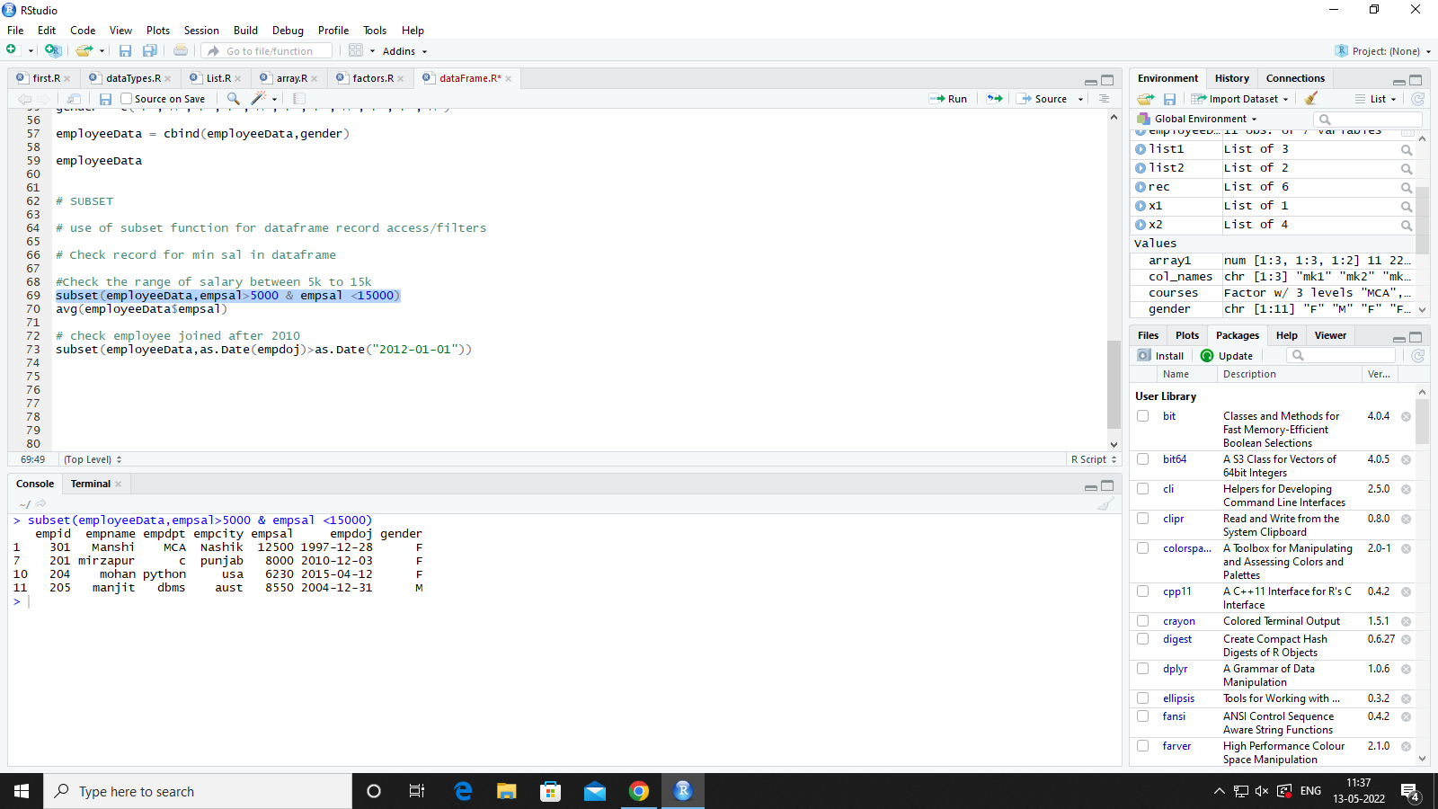

**Practical 11**

**Read CSV Files**

data = read.csv("D:\\Praful Karan\\R Programing\\data.csv") # read file from given location

data

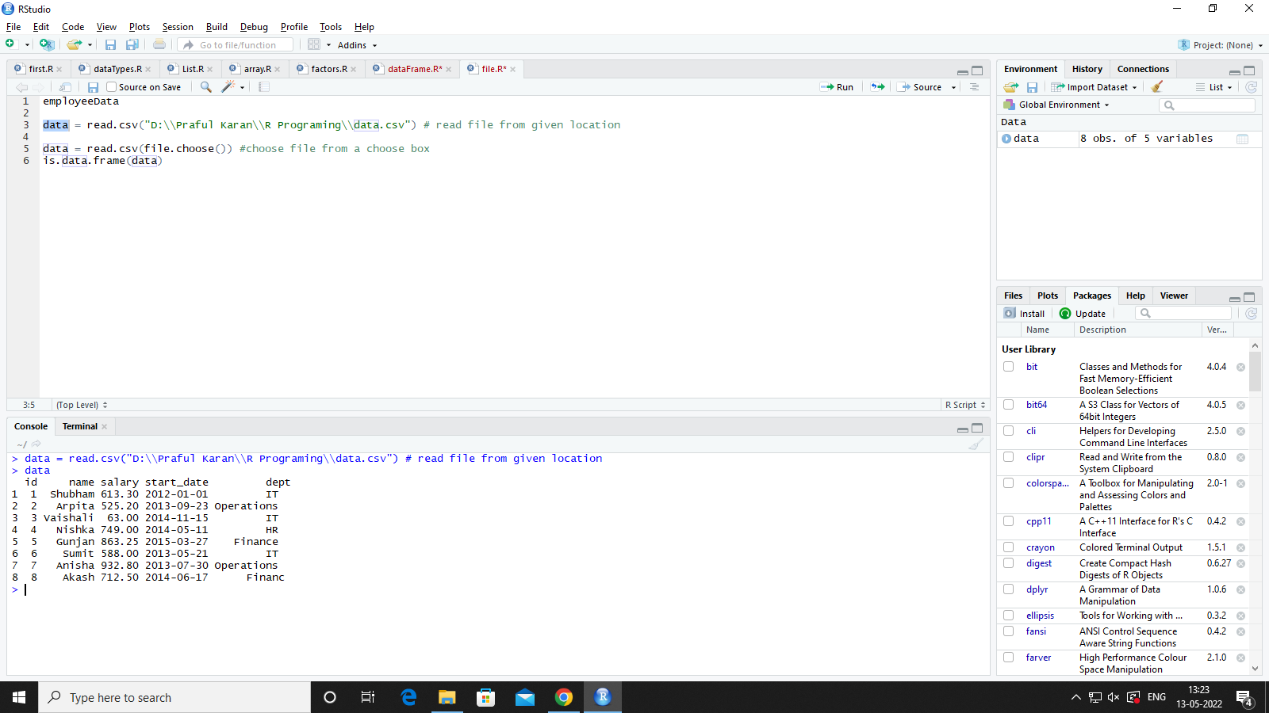

data = read.csv(file.choose()) #choose file from a choose box

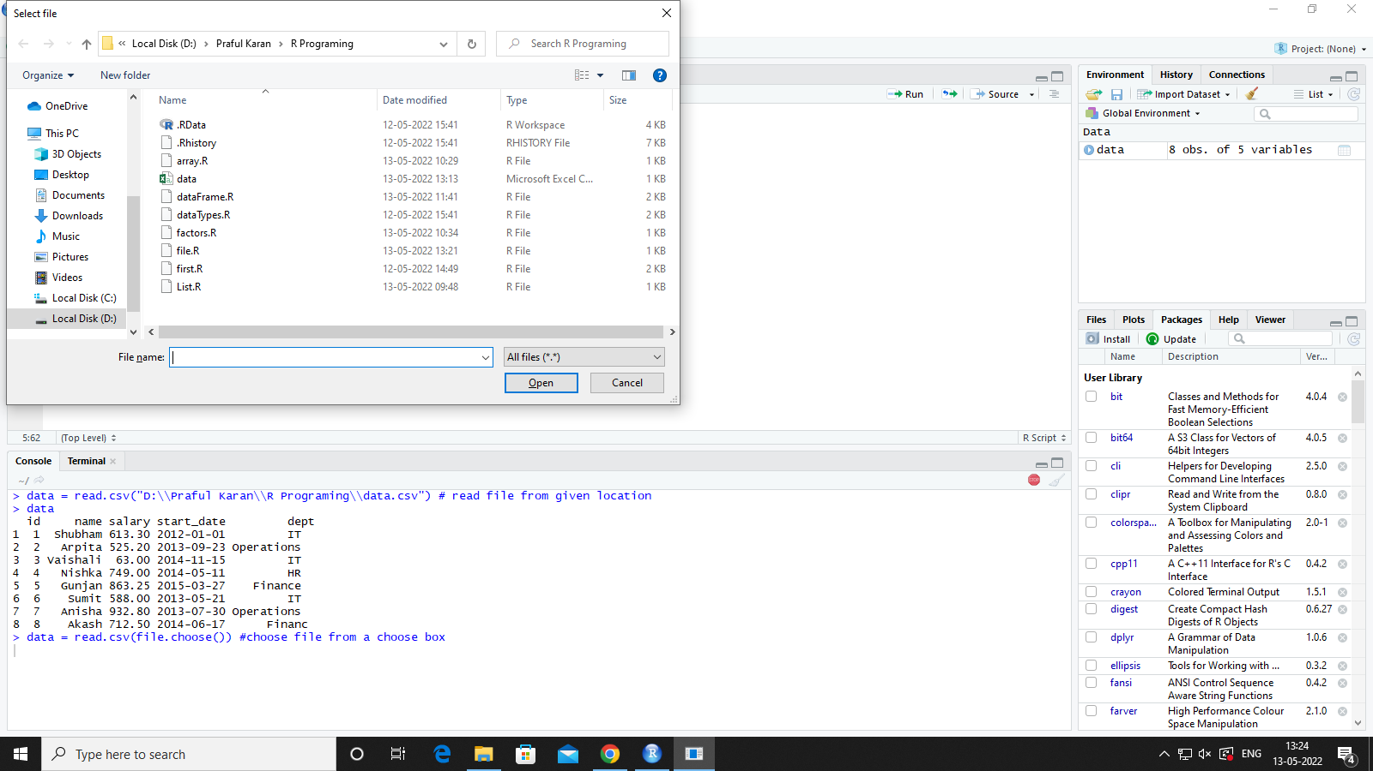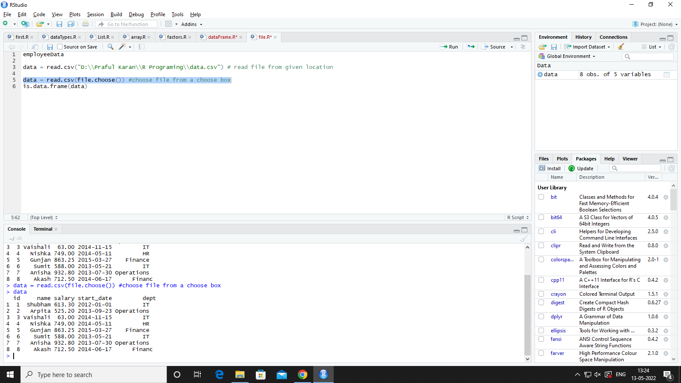

**Write CSV Files**

empdata = data.frame(

empid = c(101,102,103,104,105),

empname = c("praful","karan","rahul","aman","rohan"),

empdpt = c("java",".net","php","java",".net"),

empcity = c("patna","mumbai","kolkata","delhi","nalanda"),

empsal = c(20000,25000,45000,65230,78550),

empdoj = c("2012-02-14","2015-04-12","2012-02-14","2015-04-12","2004-12-31"),#yyyy-mm-dd

gender = c("M","F","M","F","M"),

stringsAsFactors = FALSE

)

empdata

empdata1 = data.frame(

empid = c(201,202,203,204,205),

empname = c("mirzapur","abhi","rohan","mohan","manjit"),

empdpt = c("c","c++","html","python","dbms"),

empcity = c("punjab","Kerala","bangladesh","usa","aust"),

empsal = c(8000,2000,5000,6230,8550),

empdoj = c("2010-12-03","2008-06-25","2012-02-14","2015-04-12","2004-12-31"),#yyyy-mm-dd

gender = c("M","F","M","F","M"),

stringsAsFactors = FALSE

)

empdata1

write.csv(empdata,"emp.csv",row.names = FALSE)

write.table(empdata1,"eMP.csv",append=TRUE,sep=",",col.names = FALSE,row.names=FALSE)

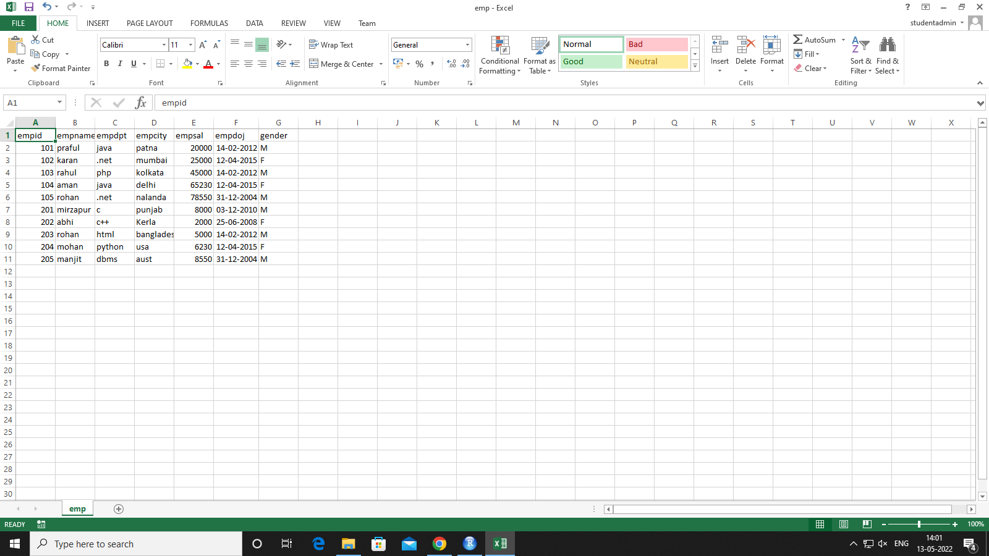

**Append CSV Files**

library(xlsx)

empdata = data.frame(

empid = c(101,102,103,104,105),

empname = c("praful","karan","rahul","aman","rohan"),

empdpt = c("java",".net","php","java",".net"),

empcity = c("patna","mumbai","kolkata","delhi","nalanda"),

empsal = c(20000,25000,45000,65230,78550),

empdoj = c("2012-02-14","2015-04-12","2012-02-14","2015-04-12","2004-12-31"),#yyyy-mm-dd

gender = c("M","F","M","F","M"),

stringsAsFactors = FALSE

)

empdata

empdata1 = data.frame(

empid = c(201,202,203,204,205),

empname = c("mirzapur","abhi","rohan","mohan","manjit"),

empdpt = c("c","c++","html","python","dbms"),

empcity = c("punjab","Kerla","bangladesh","usa","aust"),

empsal = c(8000,2000,5000,6230,8550),

empdoj = c("2010-12-03","2008-06-25","2012-02-14","2015-04-12","2004-12-31"),#yyyy-mm-dd

gender = c("M","F","M","F","M"),

stringsAsFactors = FALSE

)

empdata1

write.xlsx(empdata1,"xlsxData.xlsx",sheetName = "KJSIM",row.names = FALSE, password = "1234")

write.xlsx(empdata,"xlsxData.xlsx",sheetName = "Sheet2",row.names = FALSE, password = "1234",append=TRUE)

**OUTPUT:-**

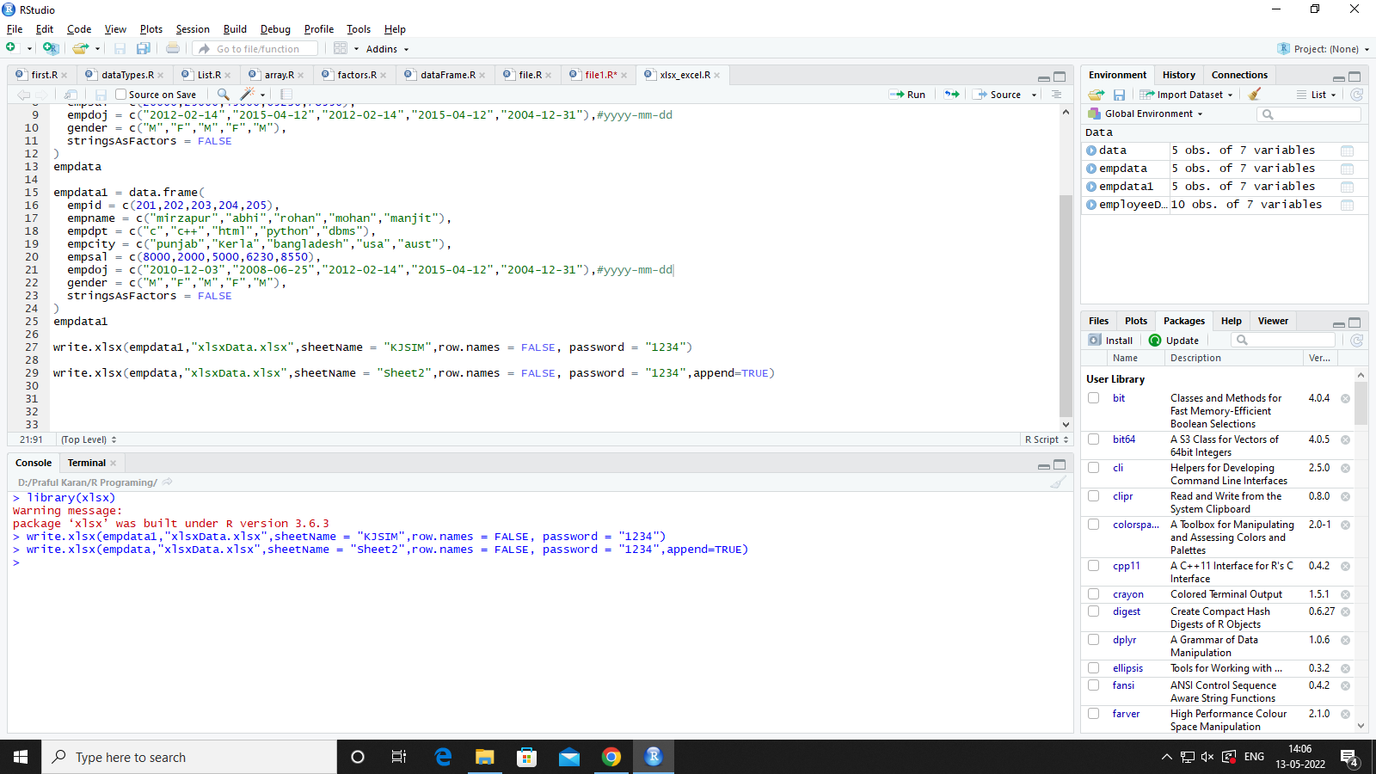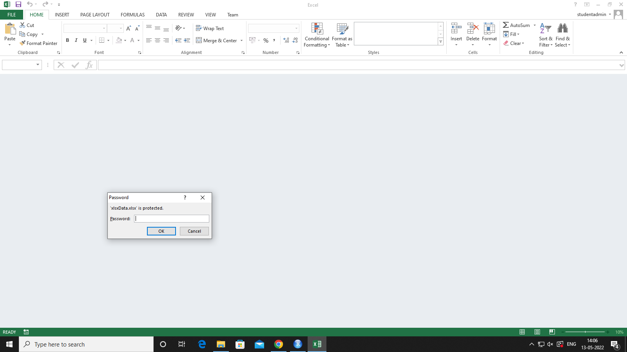

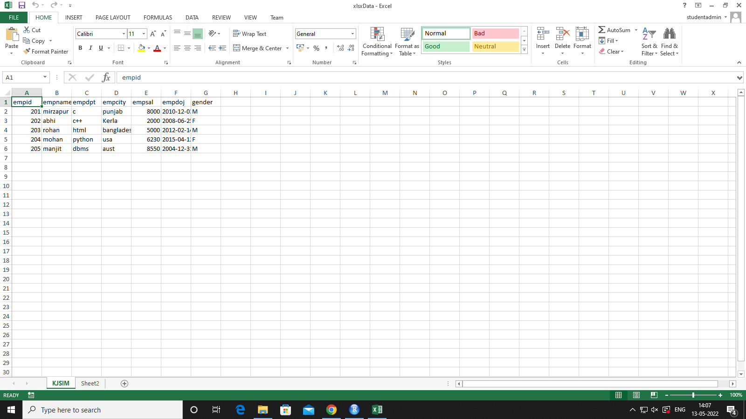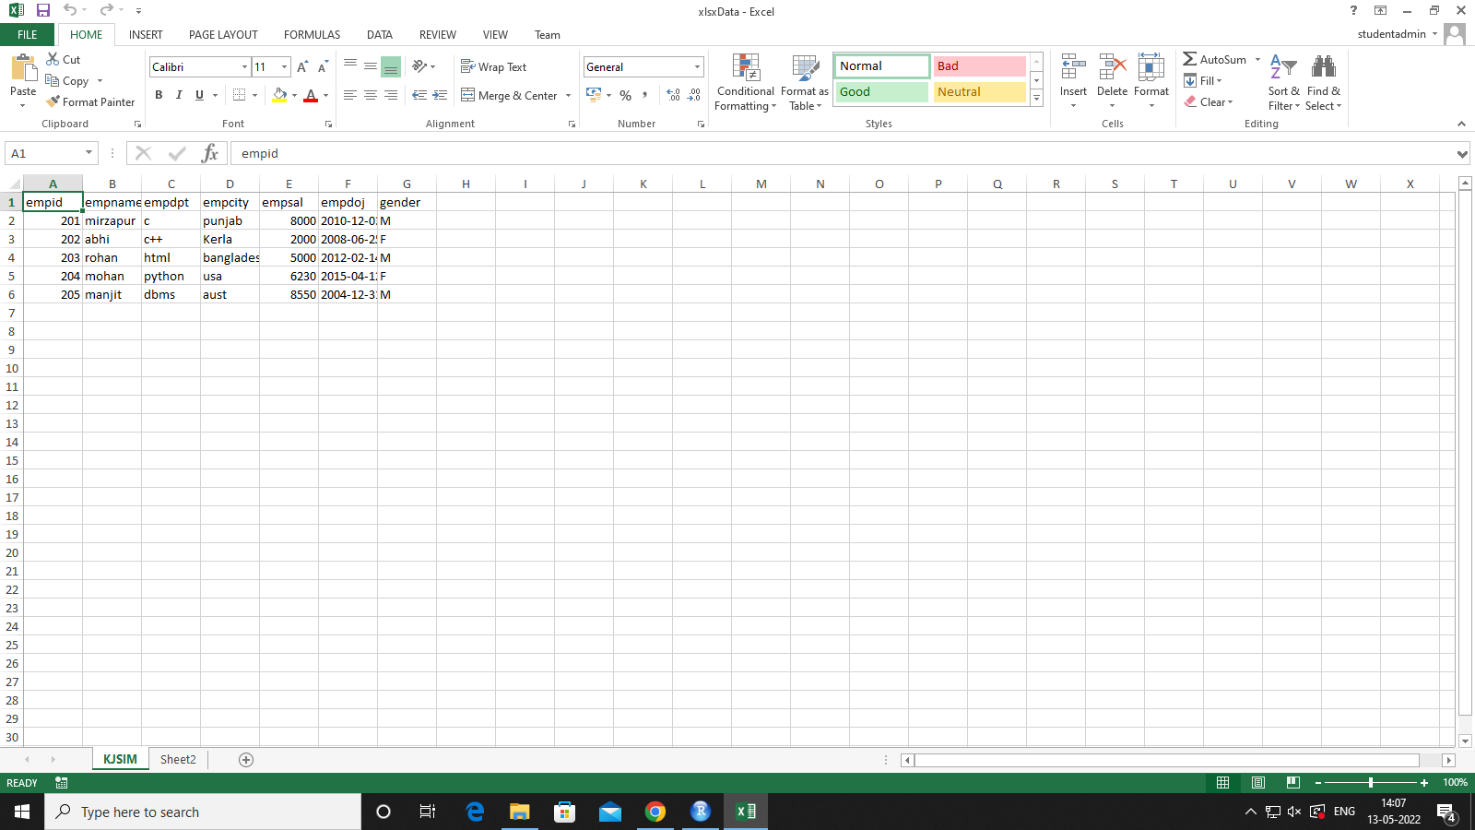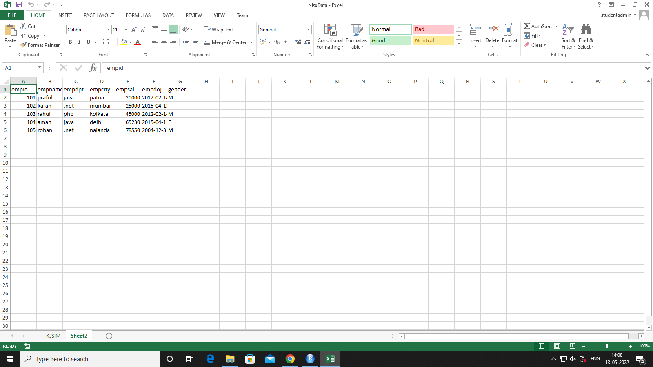

**Read CSV Files**

**1)To Read First Sheet**

read.xlsx("xlsxData.xlsx",sheetIndex =1,password = "1234")

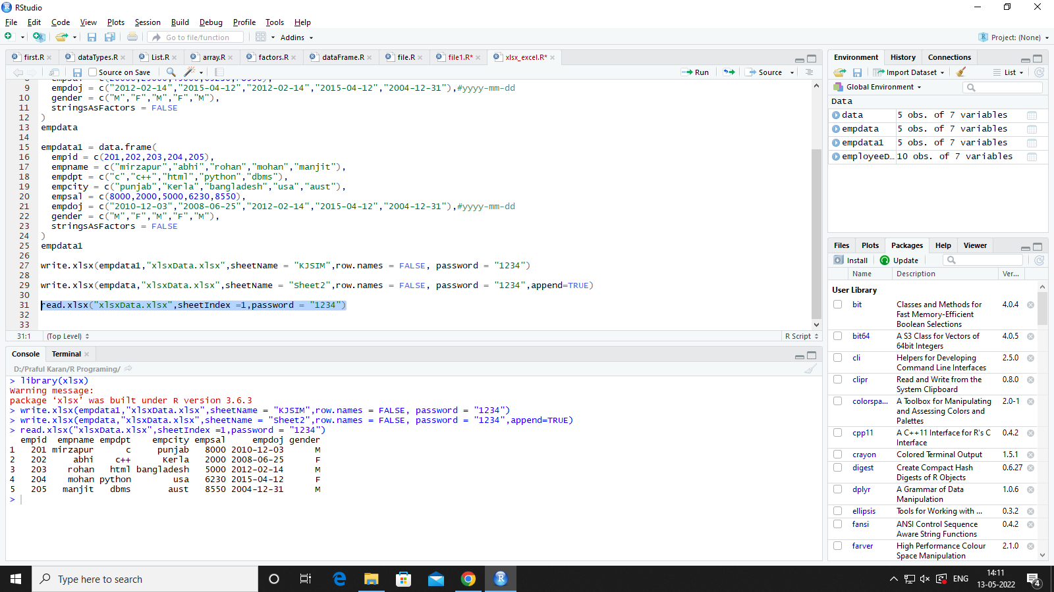

**1)To Read Second Sheet**

read.xlsx("xlsxData.xlsx",sheetIndex =2,password = "1234")

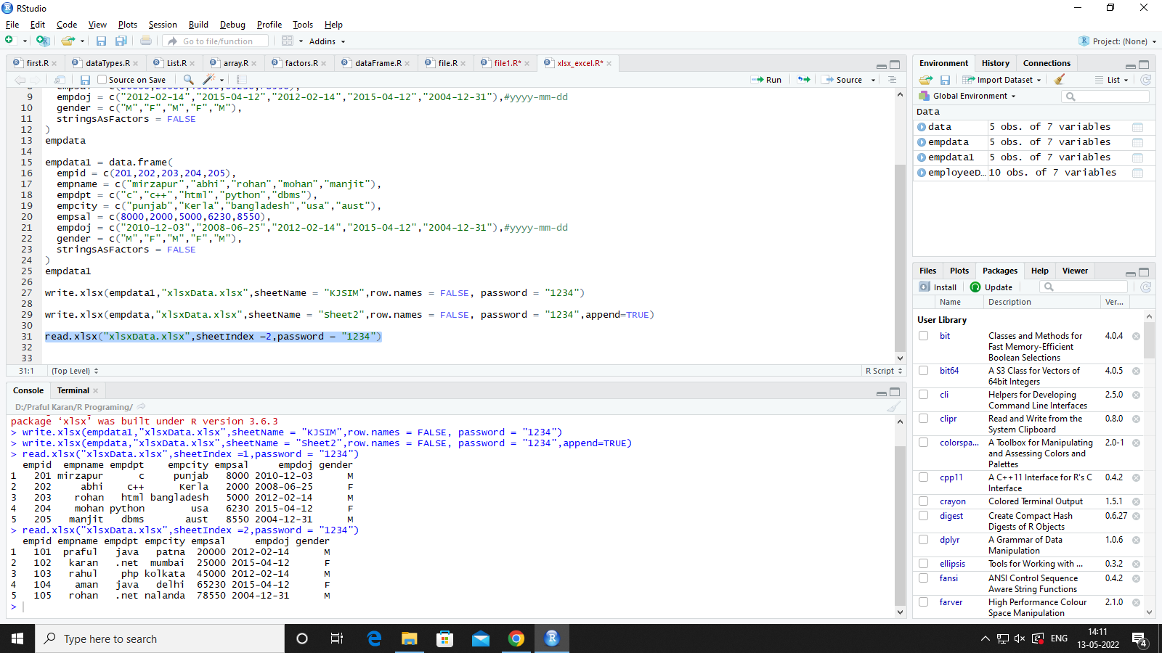

**Practical 12**

**Read Json Files**

library(RJSONIO)

# from json data in json format only

jasonEmpData = fromJSON("D:\\Praful Karan\\R Programing\\data.json")

jasonEmpData

#convert json data into dataframe before reading

jsonEmpData = as.data.frame(jasonEmpData)

jsonEmpData

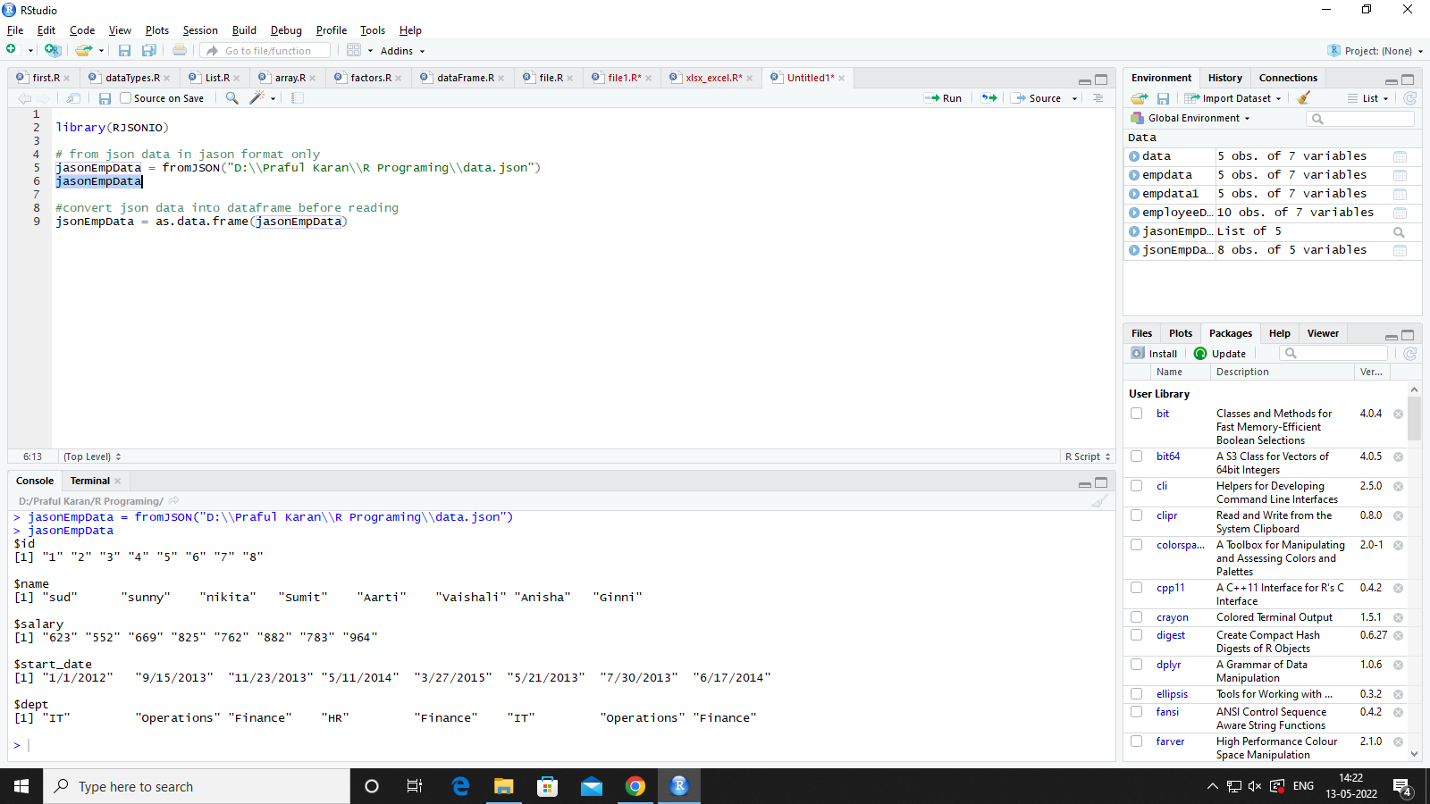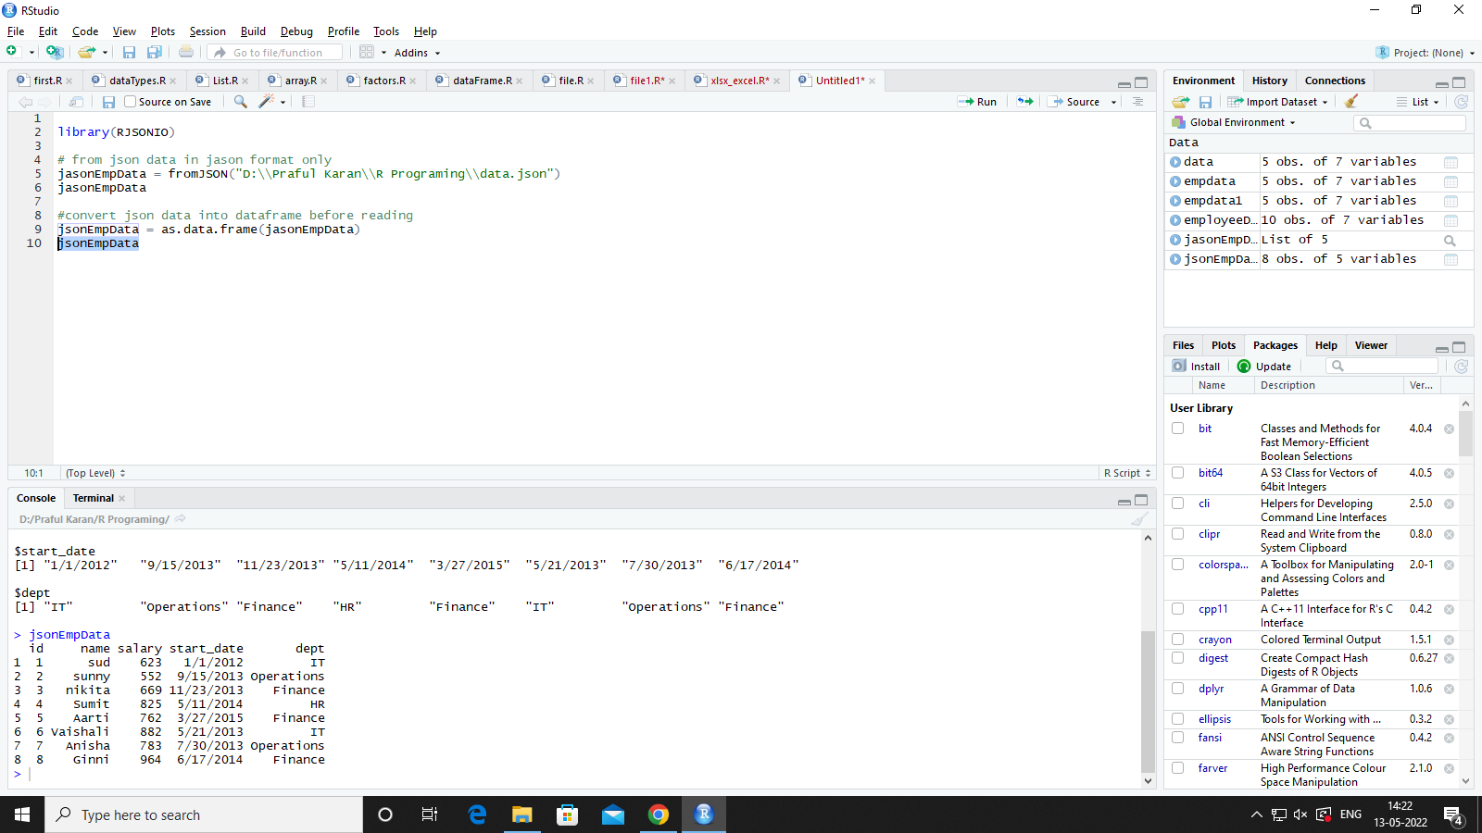

**Practical 13**

**Read XML Files**

library(XML)

data = xmlParse("D:\\Praful Karan\\R Programing\\xmlData.xml")

data

xml2dataFrame = xmlToDataFrame(data)

xml2dataFrame

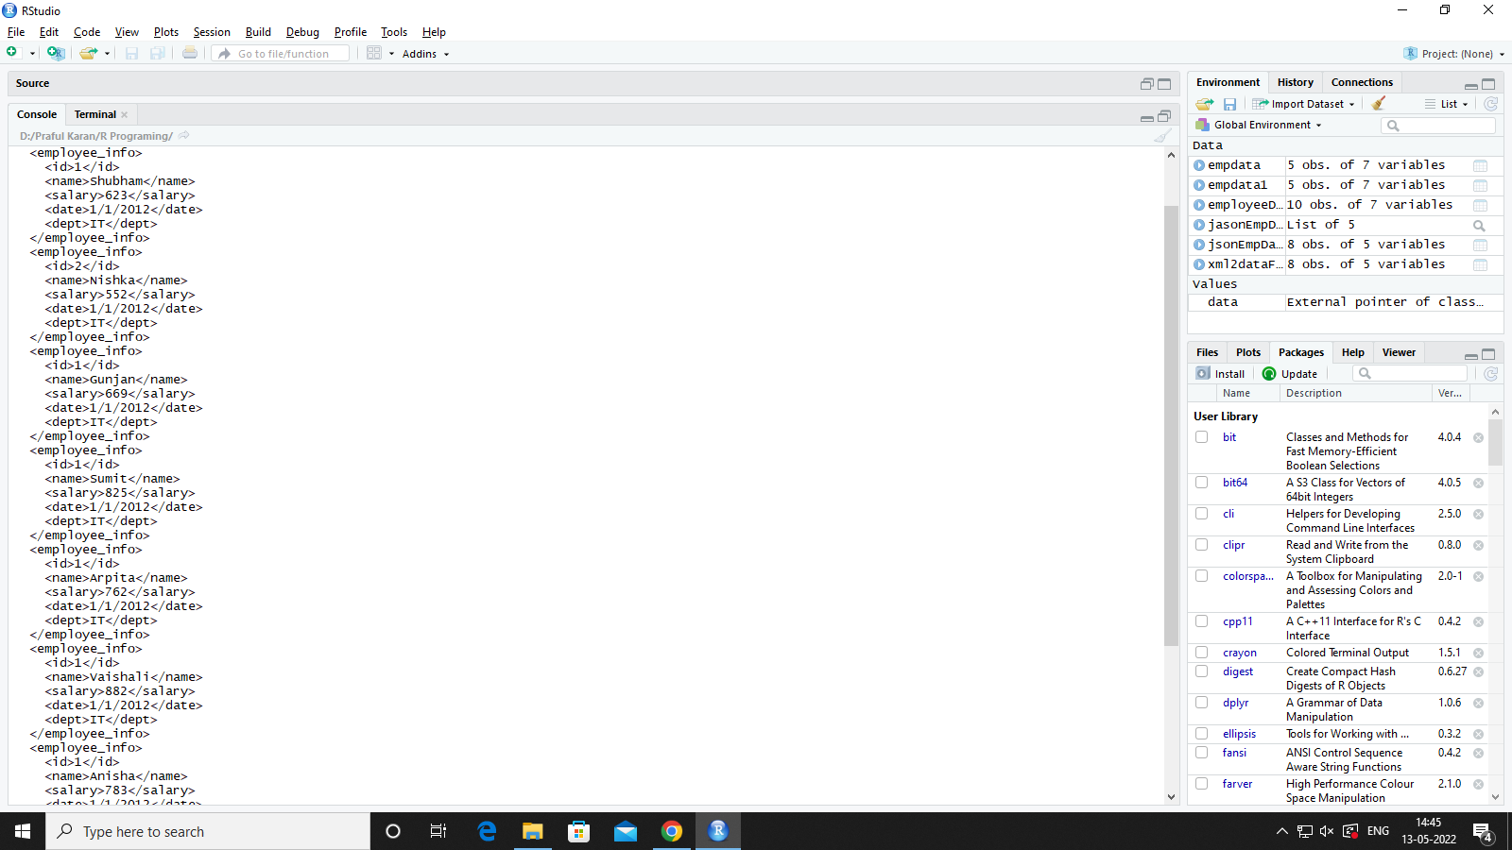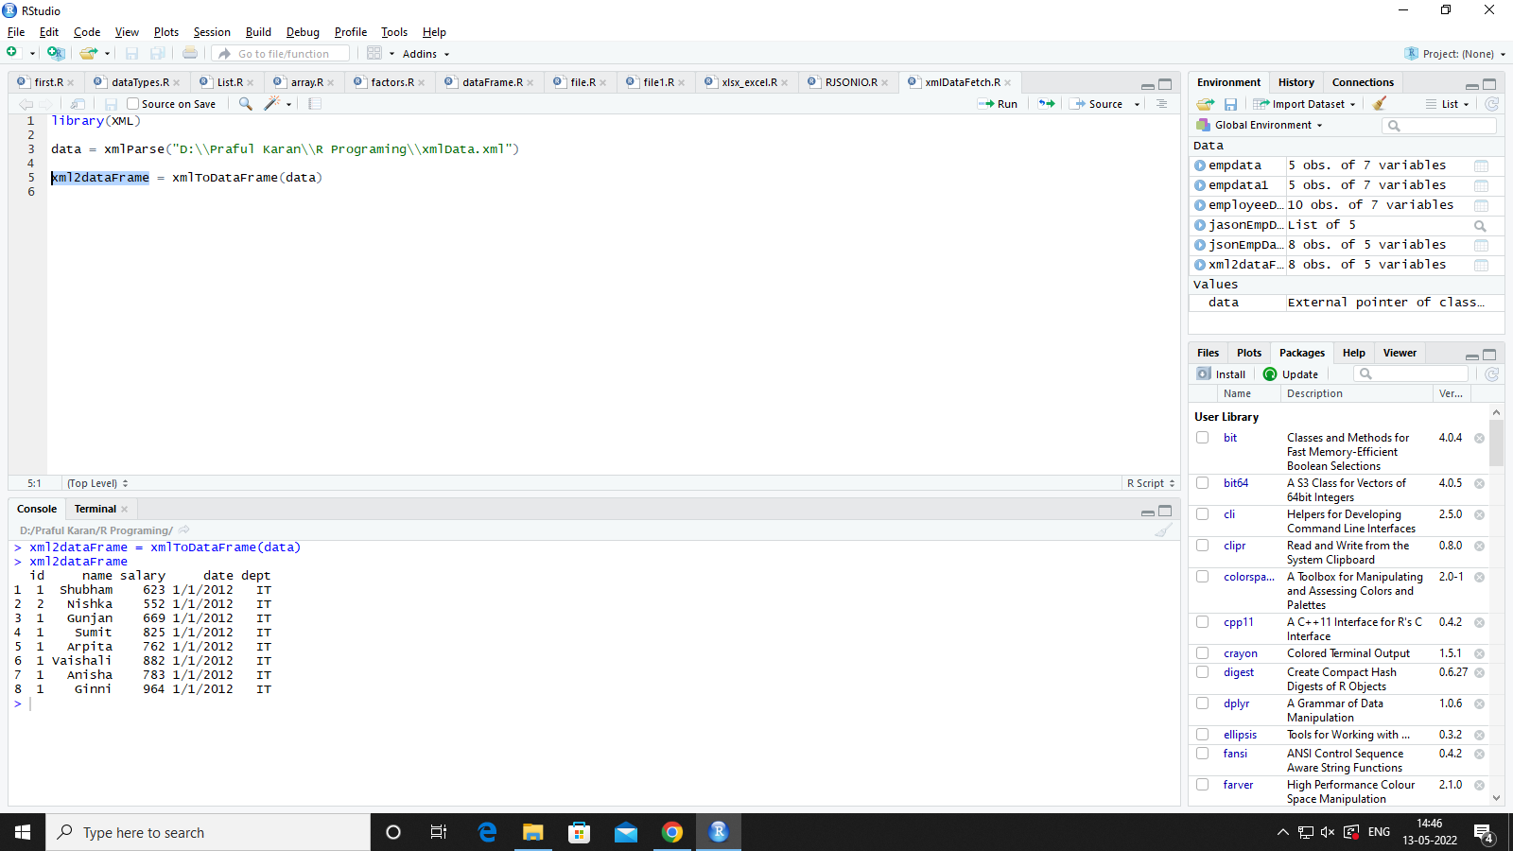

**Practical 14**

**Read Write IN Mysql Database**

library(RMySQL)

connection = dbConnect(MySQL(),user="root",password="",dbname="student",host="localhost")

data = dbSendQuery(connection,"select * from student")

empRec = fetch(data,n=-1)

empdata

dbWriteTable(connection,"table1",empdata)

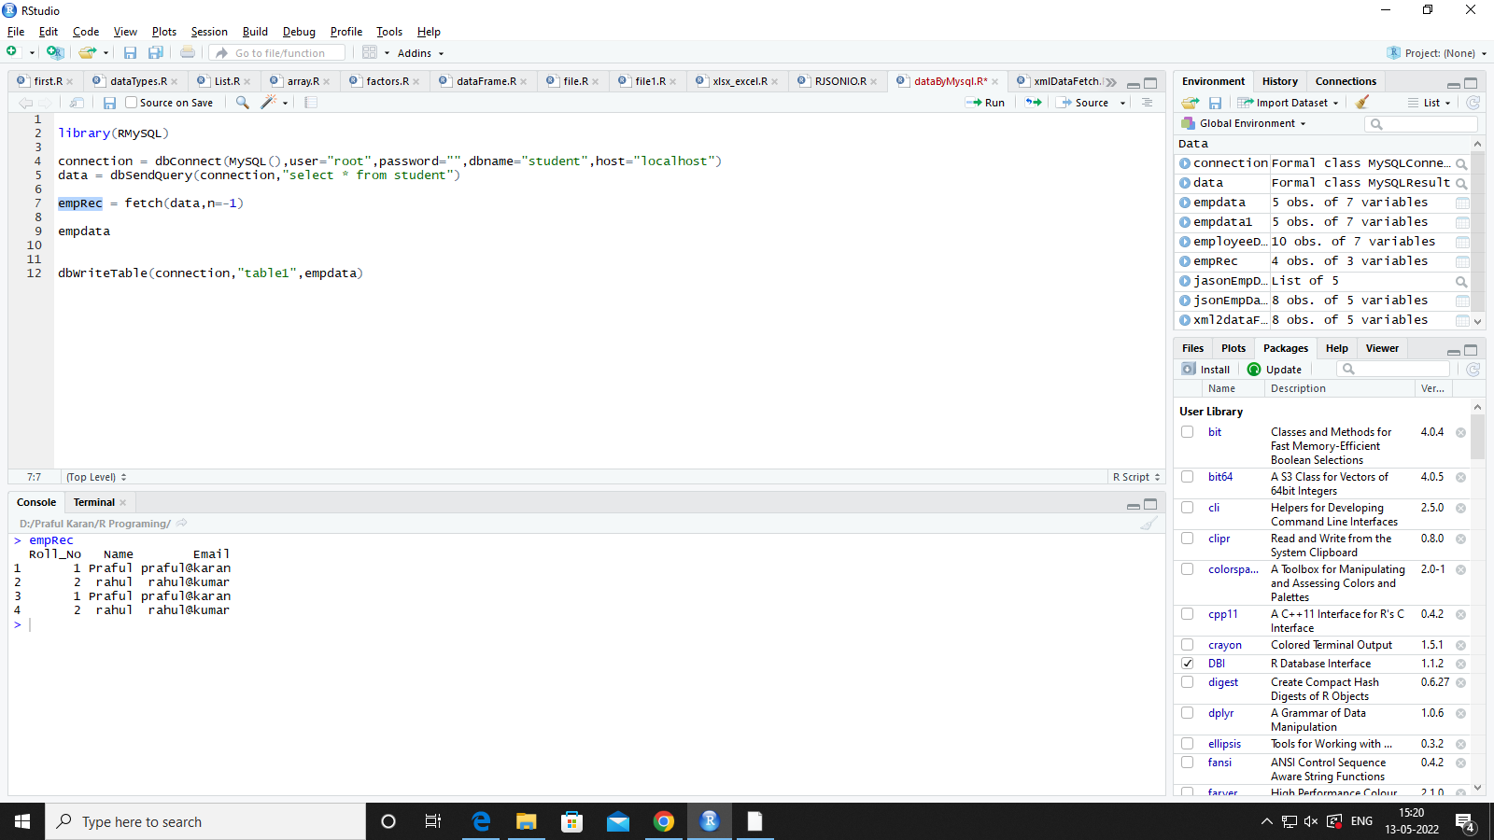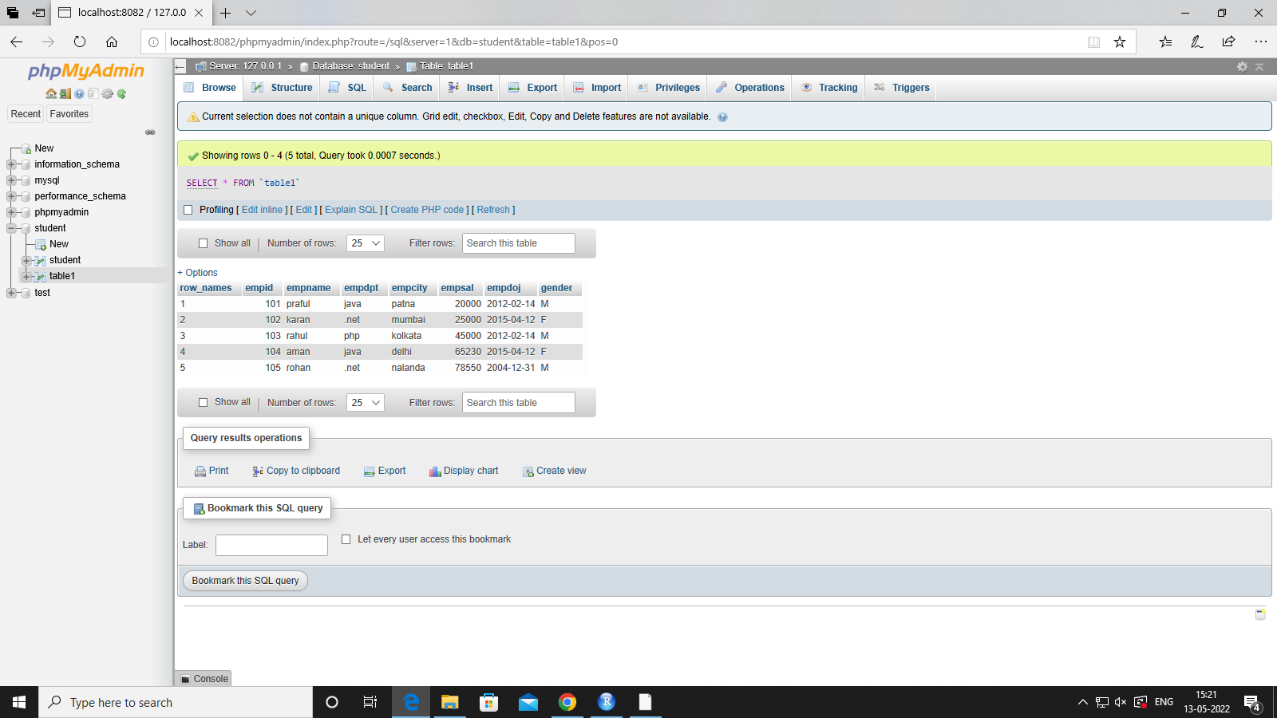

**GRAPHS**

**Practical:- 15**

**Create A Pie Chart**

**2D PIE CHART**

exportStats = c(40,23,60,55,5)

countries = c("usa","russia","india","france","sriLanka")

png("piegraph.jpeg")

pie(exportStats,labels = countries)

# saving the files

dev.off()

getwd()

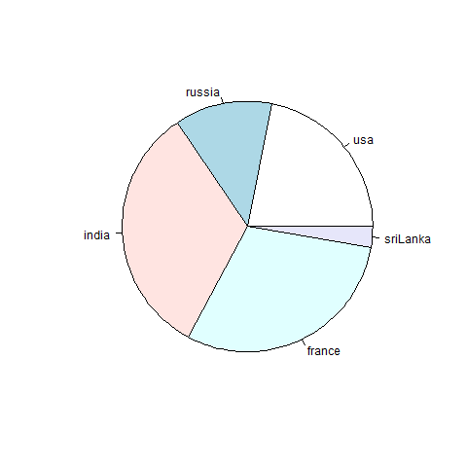

**Legend,Percent,Labels,colors**

exportStats = c(40,23,60,55,5)

countries = c("usa","russia","india","france","sriLanka")

percent = round(100*exportStats/sum(exportStats),2)

png("piegraph1.png")

pie(exportStats,main="Country Wise Export in Millions" ,labels = percent,col = rainbow(length(exportStats)))

# saving the files

legend("bottomright",legend = countries,fill = rainbow(length(exportStats)))

dev.off()

getwd()

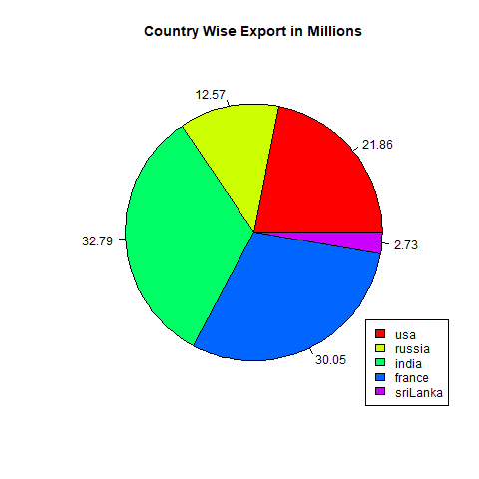

**3D PIE CHART**

# Install plotrix package for 3d pie charts

library(plotrix)

exportStats = c(40,23,60,55,5)

countries = c("usa","russia","india","france","sriLanka")

png("piegraph_3d_1.jpeg")

# saving the files

pie3D(exportStats,explode = 0.2,cex=0.8,main="Country Wise Export in Millions" ,labels = percent,col = rainbow(length(exportStats)))

legend("bottomright",cex=0.9,legend = countries,fill = rainbow(length(exportStats)))

dev.off()

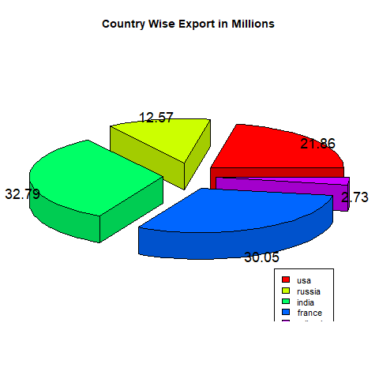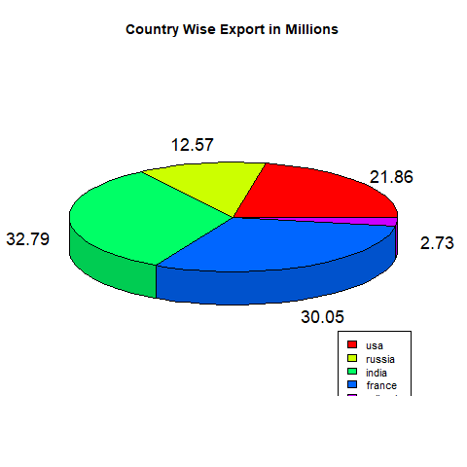

**Practical:- 16**

**Create A Bar Chart**

#BAR CHART

png("barplots.jpeg")

exportStats = c(40,23,60,55,5)

countries = c("usa","russia","india","france","sriLanka")

barplot(exportStats,names.arg = countries,xlab = "countries",ylab = "Exports in Millions",main="barplot-country wise export in millions",col=rainbow(length(exportStats)))

dev.off()

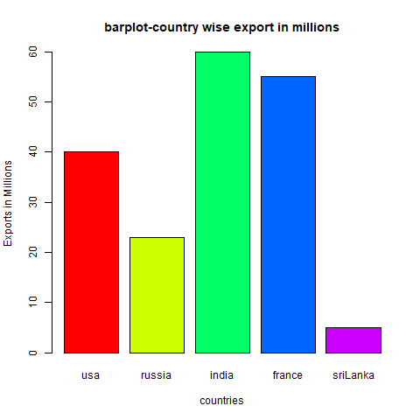

**Legend,Percent,Labels,colors**

png("barplots.jpeg")

exportStats = c(40,23,60,55,5)

countries = c("usa","russia","india","france","sriLanka")

barplot(exportStats,names.arg = countries,xlab = "countries",ylab = "Exports in Millions",main="barplot-country wise export in millions",col=rainbow(length(exportStats)))

legend("topright",cex=1.2,legend = countries,fill = rainbow(length(exportStats)))

dev.off()

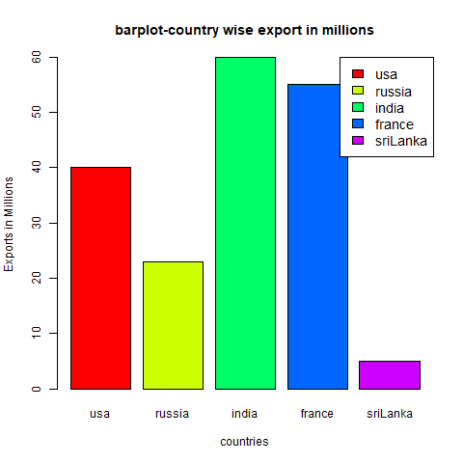

**We can show multiple trades of country in one bar to do that we use matrix**

#BAR CHART

png("barplots.jpeg")

exportStats = matrix(c(40,23,60,55,5,23,45,32,78,32,12,33,12,52,69),nrow = 3, ncol=5,byrow = TRUE)

countries = c("usa","russia","india","france","sriLanka")

sectors = c("defense","fmcg","toys")

barplot(exportStats,names.arg = countries,xlab = "countries",ylab = "Exports in Millions",main="barplot-country wise export in millions sector specifics",col=rainbow(length(exportStats)))

legend("topright",cex=1.2,legend = sectors,fill = rainbow(length(exportStats)))

dev.off()

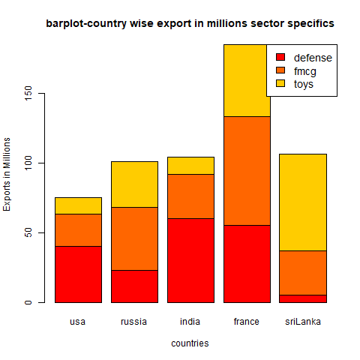

**Box plot**

mtcars

png("boxPlot.jpeg")

boxplot(mtcars$mpg~mtcars$cyl,xlab = "number of cylinders",ylab = "milage per gallons",col="red",notch=TRUE)

dev.off()

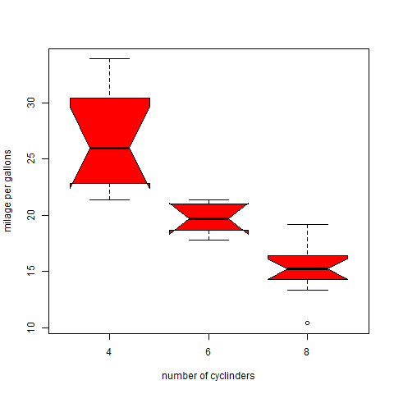

# box plot

mtcars

png("boxPlot.jpeg")

boxplot(mtcars$mpg~mtcars$cyl,xlab = "number of cylinders",ylab = "mileage per gallons",col="red",notch=TRUE,**horizontal = TRUE**)

dev.off()

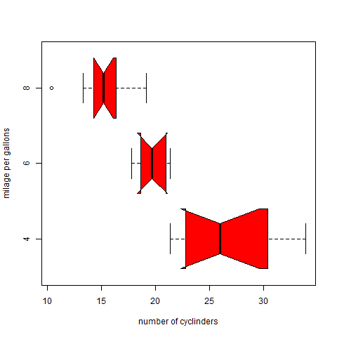

**BACKPLOT**

library(aplpack)

png("aplpack_image.jpeg")

bagplot(mtcars$wt,mtcars$mpg,xlab="number of cylinder",ylab="Millage per gallon")

dev.off()

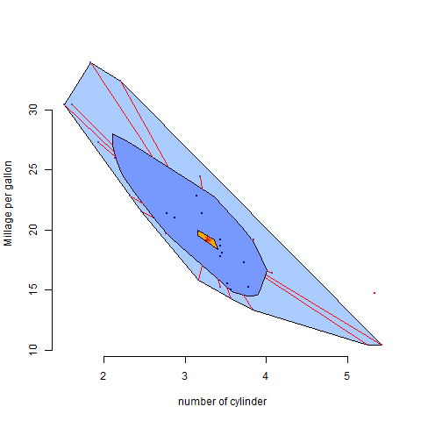

**Practical:- 16**

**Create A Histogram**

**a)Without Breaks**

airquality

png("histogram1.jpeg")

hist(airquality$Temp, main="temp ovserved at ch. shivaji maharaj Int Airport",xlim=c(50,100),col = "red")

dev.off()

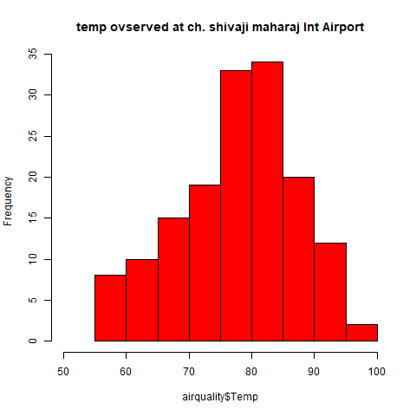

**b)With Breaks**

airquality

png("histogram1.jpeg")

hist(airquality$Temp, main="temp ovserved at ch. shivaji maharaj Int Airport",xlim=c(50,100),col = "red",breaks =c(10,20,30,40))

dev.off()

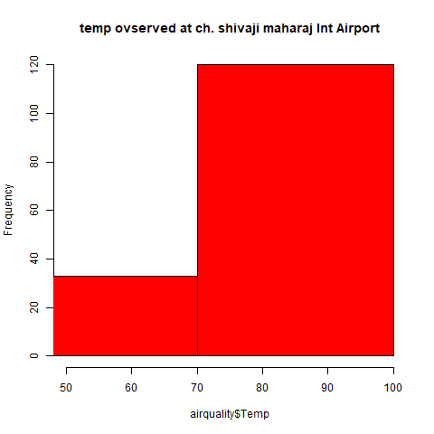

**Set label on Histogram**

airquality

png("histogram1.jpeg")

#hist(airquality$Temp, main="temp ovserved at ch. shivaji maharaj Int Airport",xlim=c(50,100),col = "red",breaks =c(10,20,30,40))

hist(airquality$Temp)

h = hist(airquality$Temp)

text(h$mids,h$counts,labels =h$counts,adj = c(0.5,-0.5) )

dev.off()

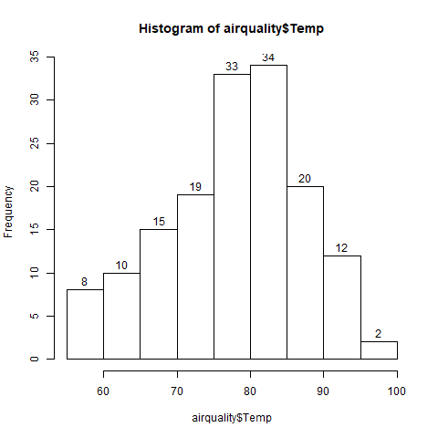

**Practical:- 17**

**Create A Line Graph**

#LIne Graph

png("linegraph1.jpeg")

#type -p(points), l(lines) , o(both points and lines)

plot(airquality$Temp,type = "l")

dev.off()

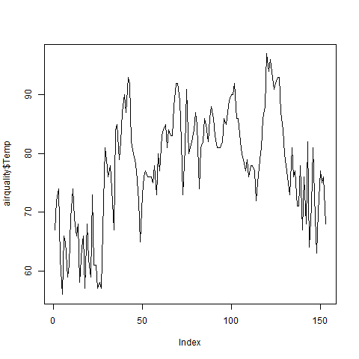

**Comparing Data in Line Graph**

png("temperature.jpeg")

temp=c(33,34,35,25,12,63,54)

humidity = c(36,33,40,20,8,70,60)

number = c(2,52,62,68,96,31,64)

plot(temp,type = "l")

lines(humidity,type="l",col="green")

lines(number,type="l",col="red")

dev.off()

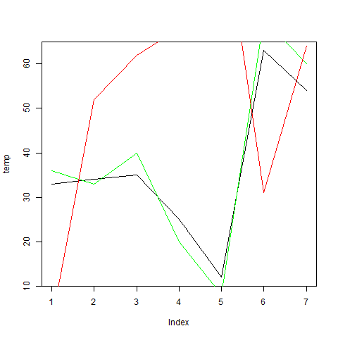

**Practical:- 18**

**Create A Scatter Plot**

**# Scatter Plot**

png("scatter_one.jpeg")

plot(x=airquality$Temp,y=airquality$Ozone)

dev.off()

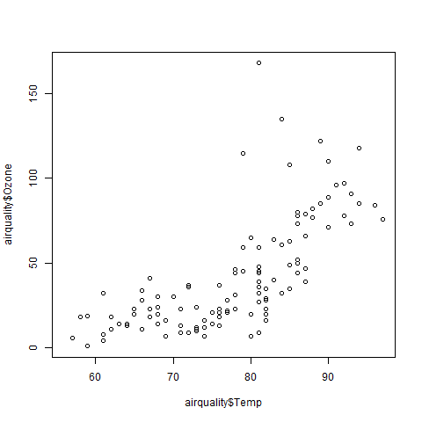

**Practical:- 19**

**Web Scraping**

library(rvest) #use in text analysis

library(dplyr)

imdb_link = "https://www.imdb.com/search/title/?title_type=feature&num_votes=25000,&genres=adventure&sort=user_rating,desc"

#read_html() returns the html code of webpage

htmlPage = read_html(imdb_link)

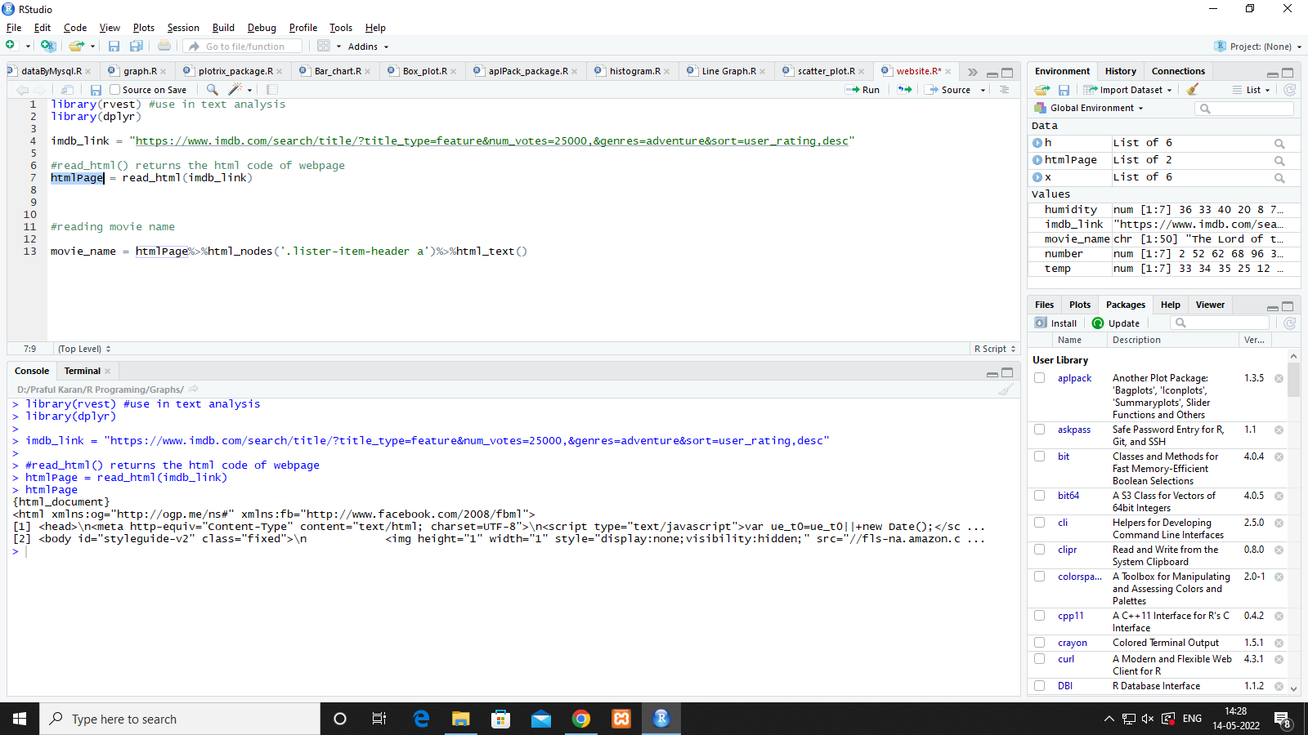

**#reading movie name**

movie_name = htmlPage%>%html_nodes('.lister-item-header a')%>%html_text()

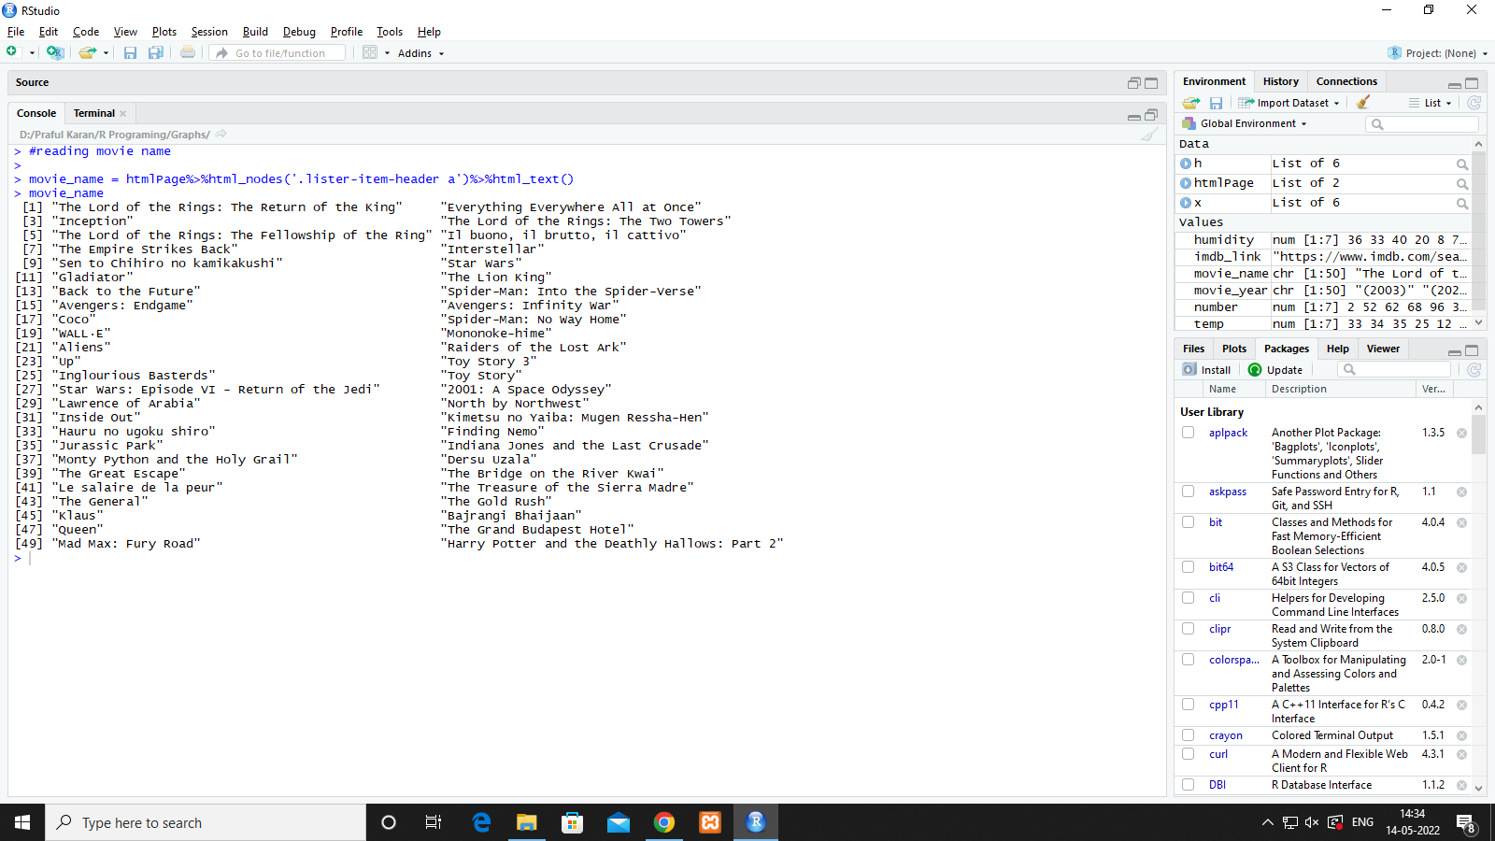

**# reading movie release year**

movie_year = htmlPage %>% html_nodes('.text-muted.unbold')%>%html_text()

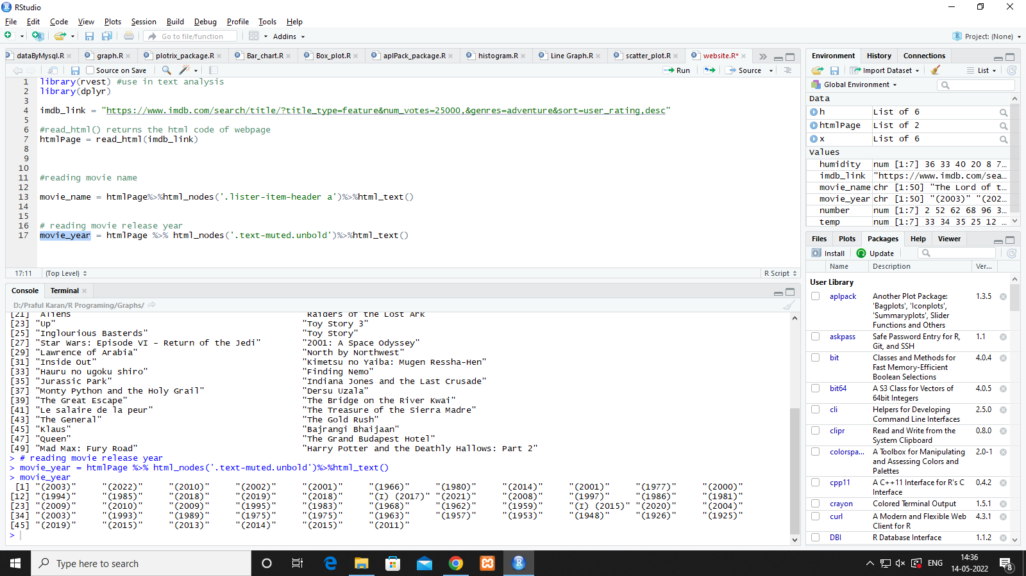

**# reading rating**

movie_rate = htmlPage %>% html_nodes('.ratings-imdb-rating strong')%>%html_text()

**#gross Income**

movie_gross=htmlPage %>% html_nodes('.ghost~ .text-muted+ span')%>%html_text()

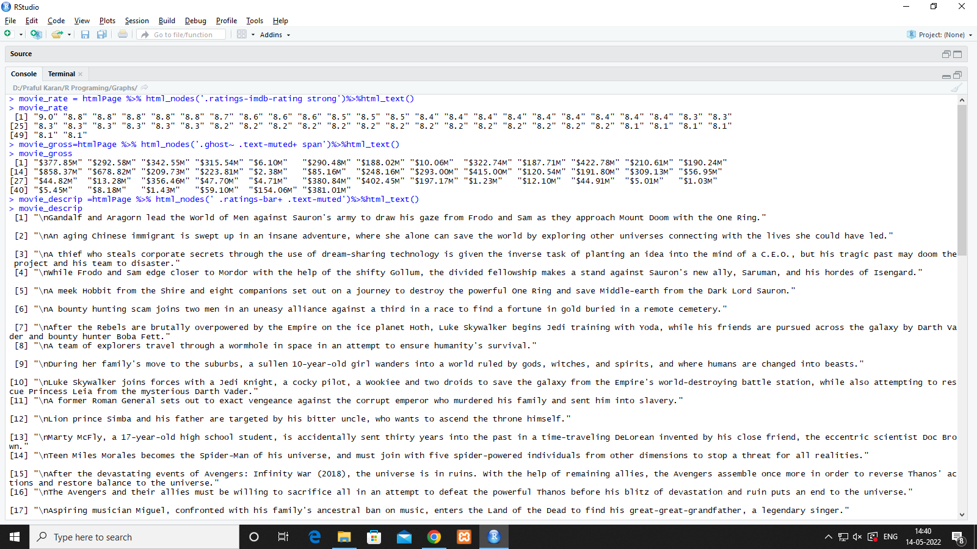

**# movie description**

movie_descrip =htmlPage %>% html_nodes(' .ratings-bar+ .text-muted')%>%html_text()

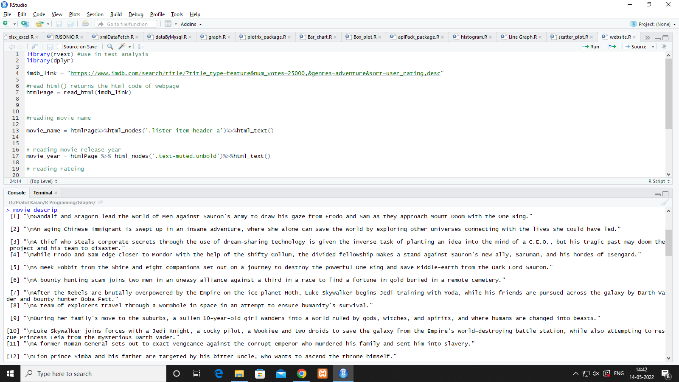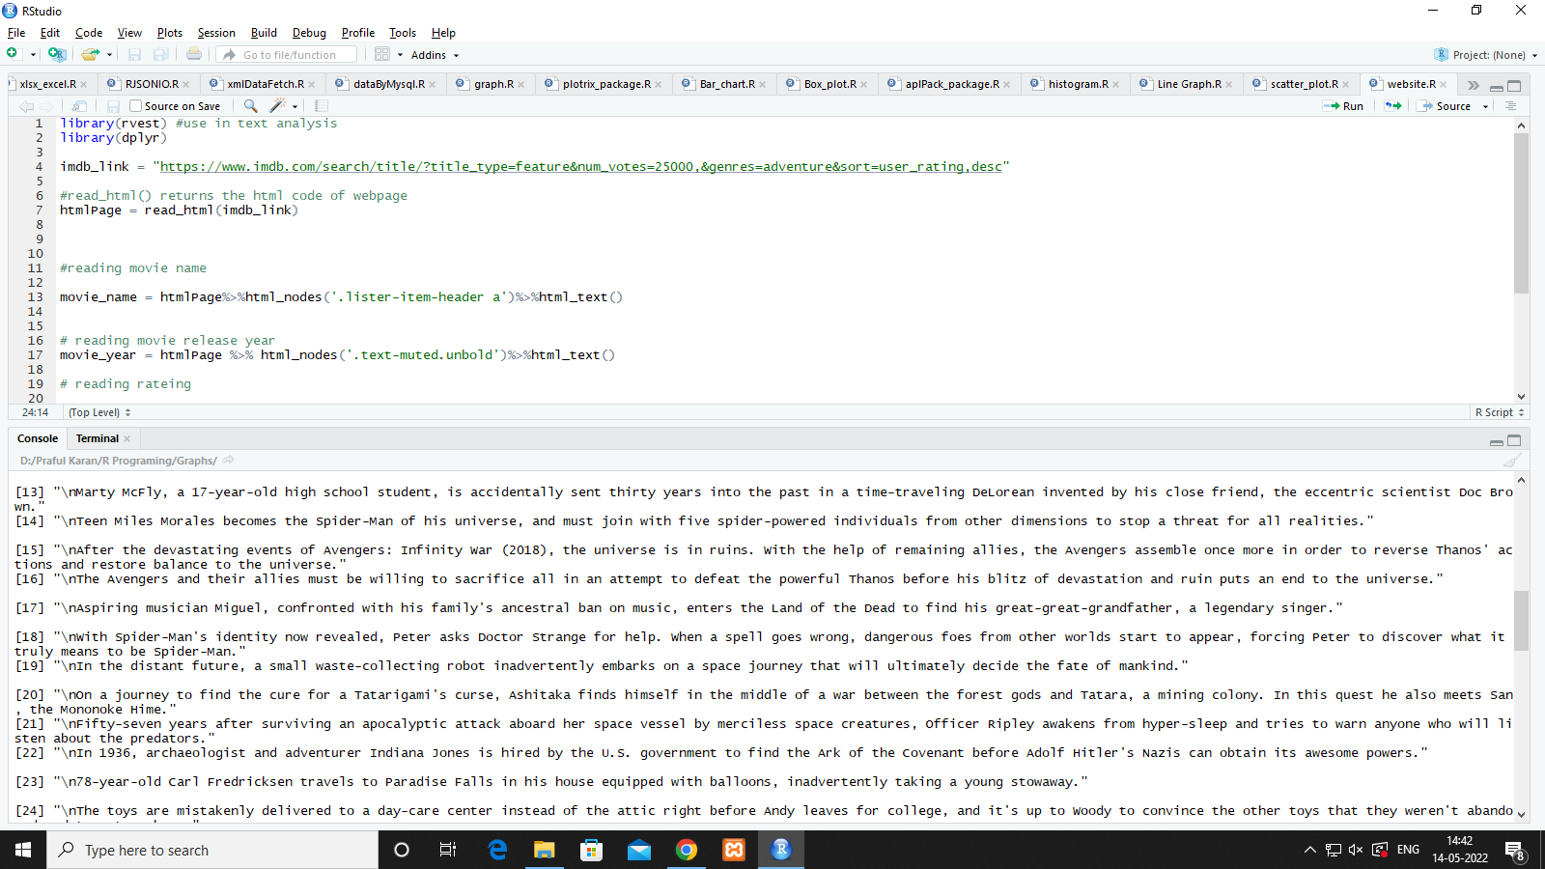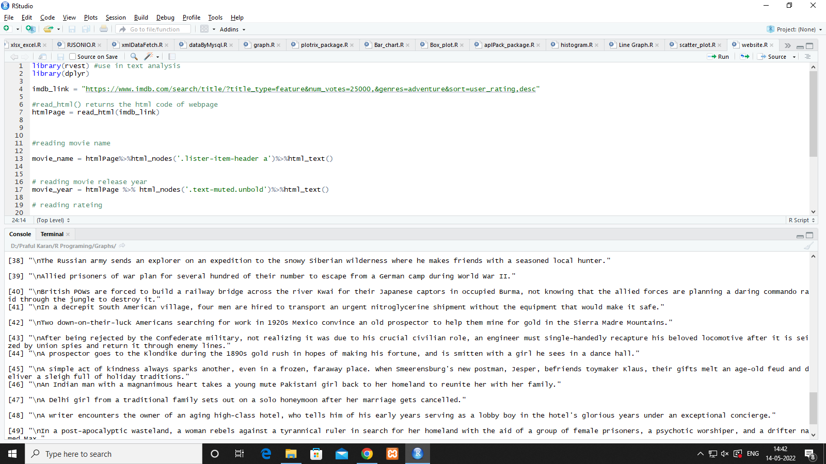

**To show in table**

top50Movie = data.frame(movie_name,movie_year,movie_rate,movie_descrip)

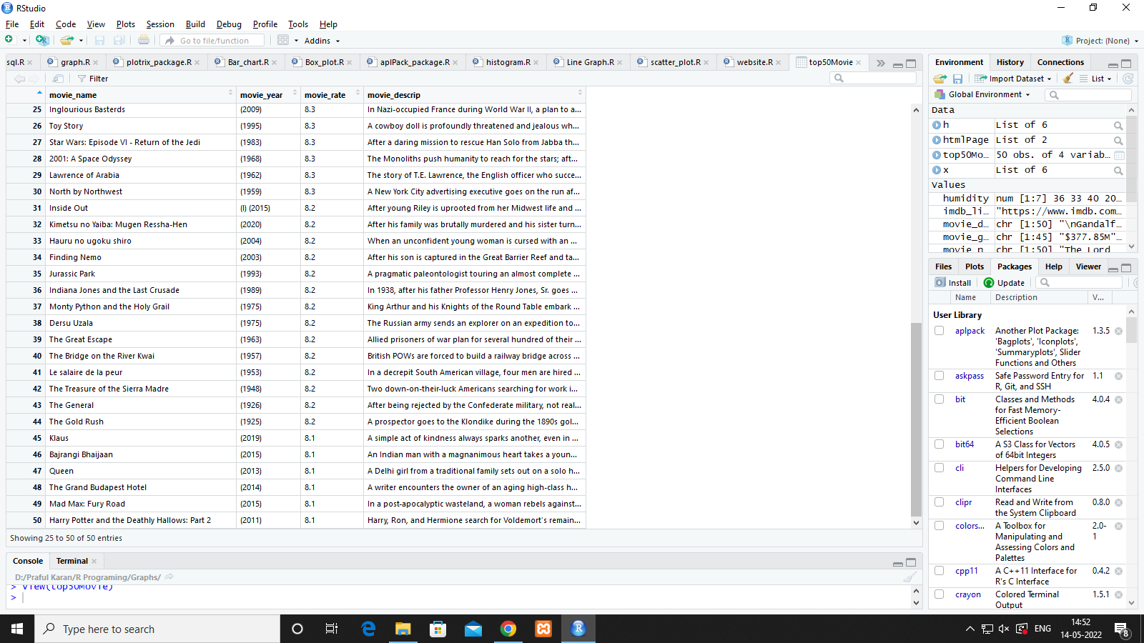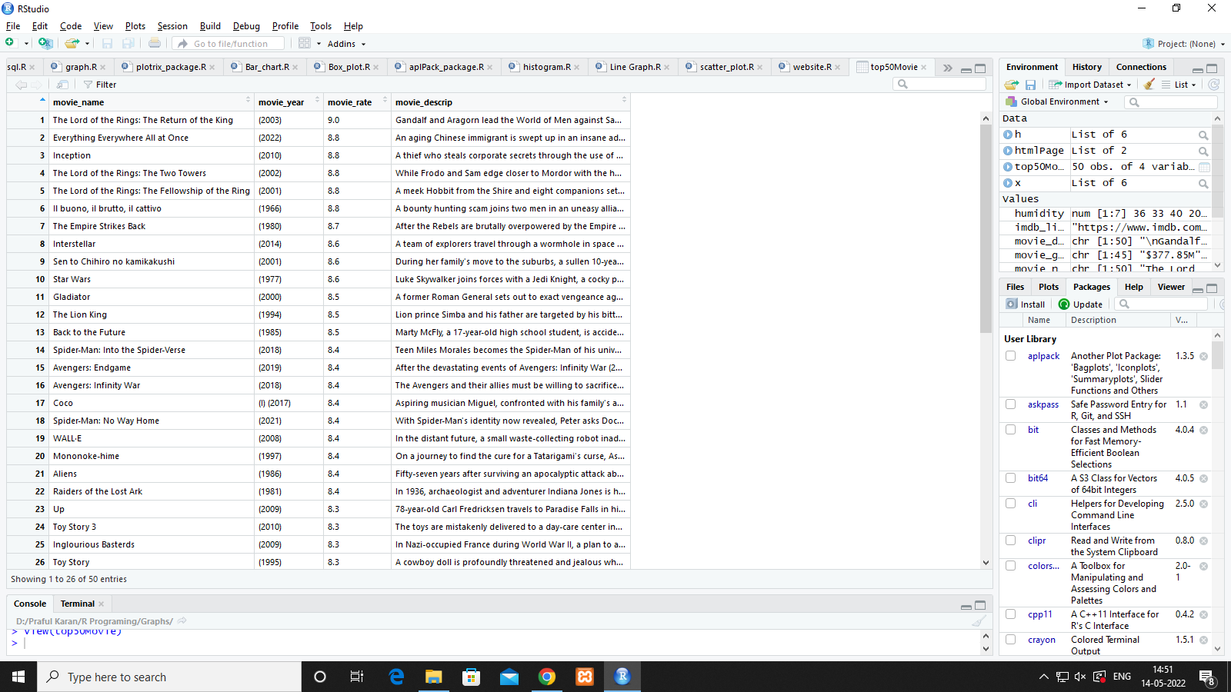

**Practical 20**

**Comparing Mean values In R analytics**

1. **Dataset**

#t-test

#data set used

attach(LungCapData)

str(LungCapData)

LungCapData$LungCap=as.double(LungCapData$LungCap)

LungCapData$Smoke = as.factor(LungCapData$Smoke)

LungCapData$Gender= as.factor(LungCapData$Gender)

png("LungCapacityBoxPlot.jpeg")

boxplot(LungCapData$LungCap)

dev.off()

#HO - null hypothesis mean lungcapacity is = 8

# h1 = true where mean < 8

oneSampleTest = t.test(LungCapData$LungCap,mu=8,alternative = "less",confint=0.95)

attributes(oneSampleTest)

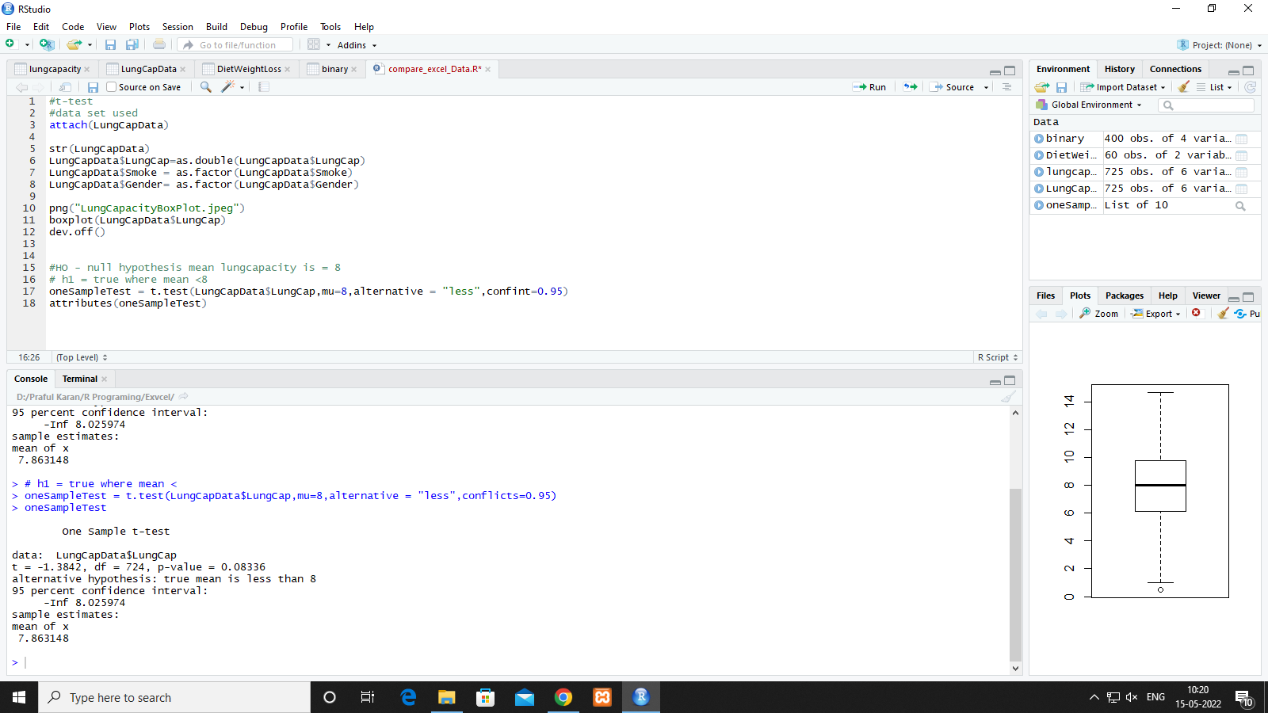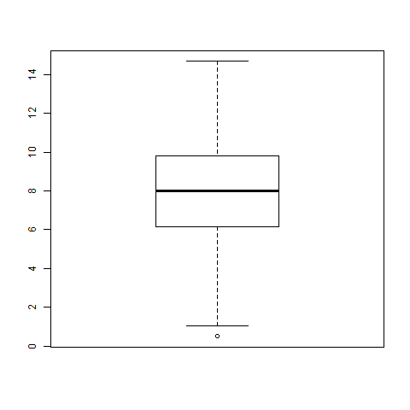

**Variables**

var(LungCapData$LungCap[Smoke=="yes"])

var(LungCapData$LungCap[Smoke=="no"])

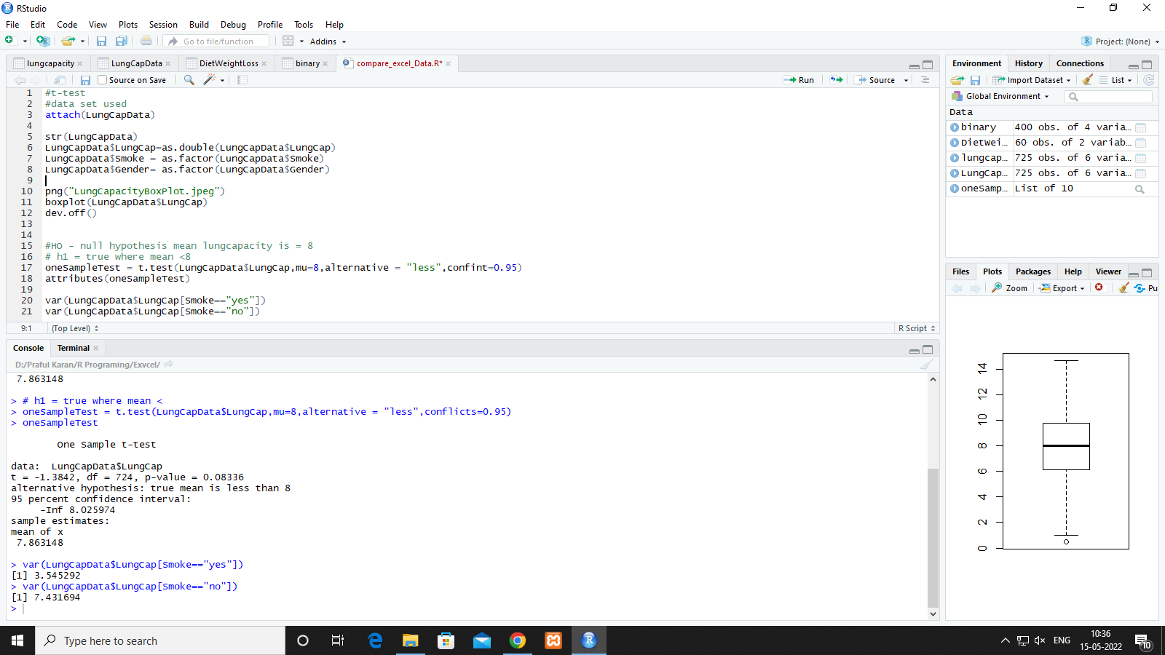

**Two Sided Test**

LungCapData

# boxplot for two sample/ two side t-side

png("LungSmoke.jpeg")

boxplot(LungCapData$LungCap~LungCapData$Smoke)

dev.off()

twoSampleTest = t.test(LungCapData$LungCap~LungCapData$Smoke,mu=0, alternative="two.sided",confint=0.95)

twoSampleTest = t.test(LungCapData$LungCap~LungCapData$Smoke)

# two sample test is default in t.test() even all parameter are default

attributes(twoSampleTest)

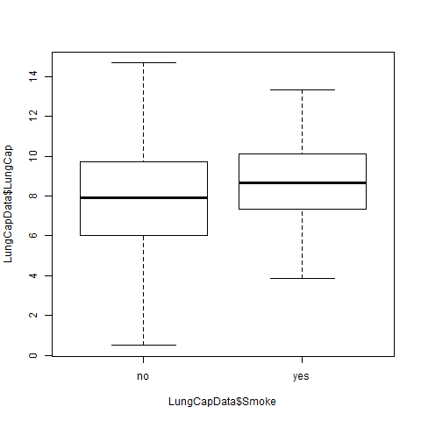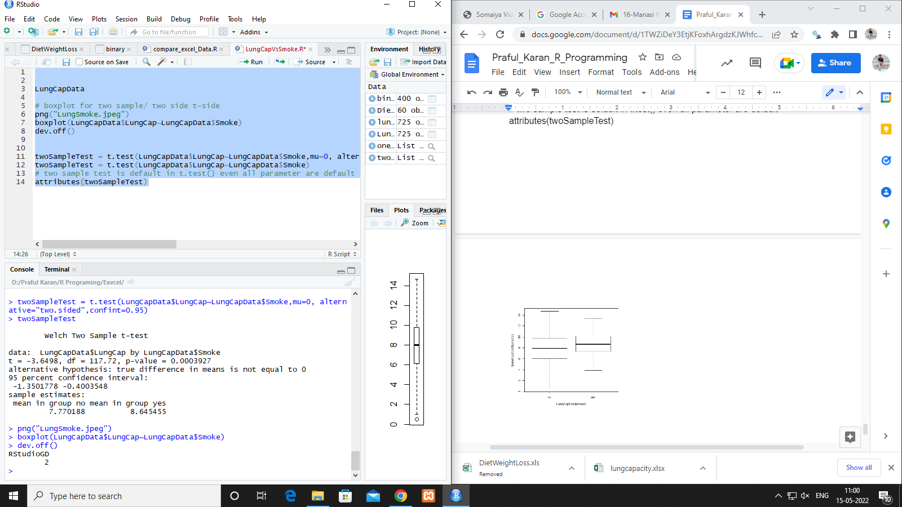

**#anova test**

attach(DietWeightLoss)

str(DietWeightLoss)

DietWeightLoss$Diet = as.factor(DietWeightLoss$Diet)

levels(DietWeightLoss$Diet)

png("WeightLoss~DietType.jpeg")

boxplot(DietWeightLoss$WeightLoss~DietWeightLoss$Diet)

dev.off()

#H0 weight loss is same for all diet types

annovaRes = aov(DietWeightLoss$WeightLoss~DietWeightLoss$Diet)

annovaRes$coefficients

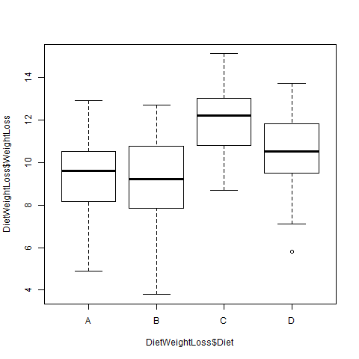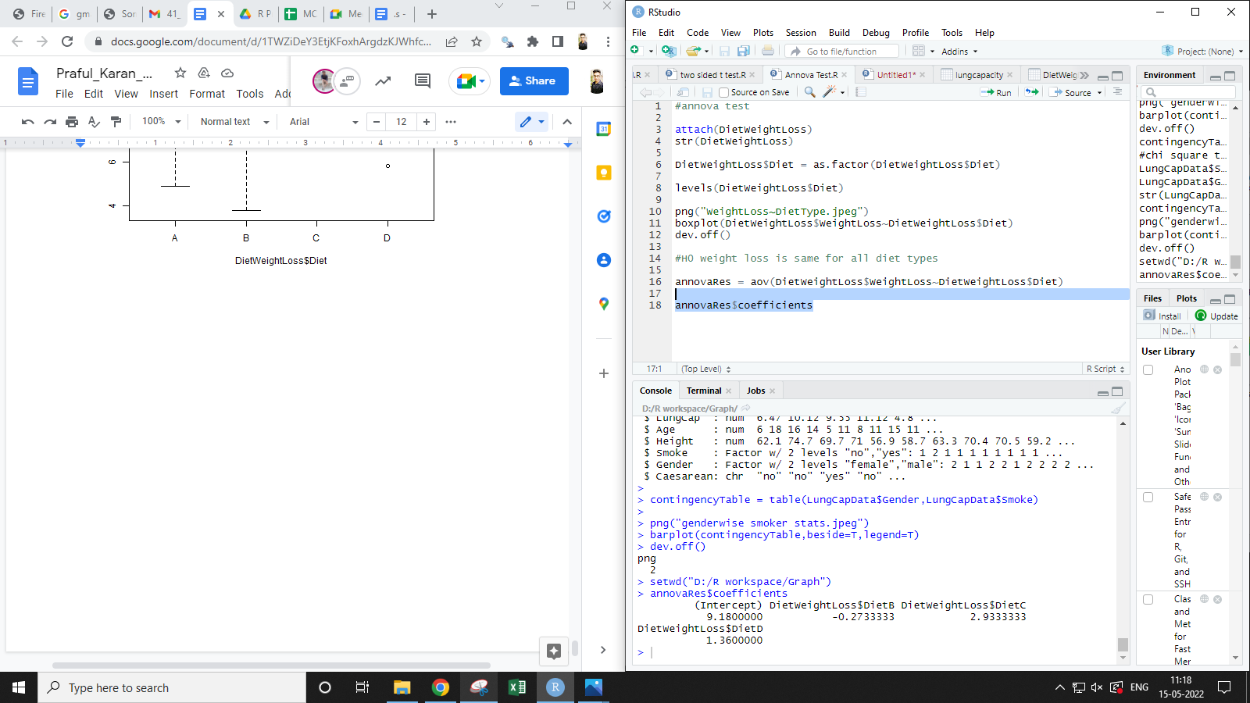

**# Chi Square Test**

LungCapData$Smoke = as.factor(LungCapData$Smoke)

LungCapData$Gender = as.factor(LungCapData$Gender)

str(LungCapData)

ContingencyTable = table(LungCapData$Gender,LungCapData$Smoke)

png("genderwiseSmoker.jpeg")

barplot(ContingencyTable,beside = T, legend=T)

dev.off()

chisq.test(ContingencyTable)

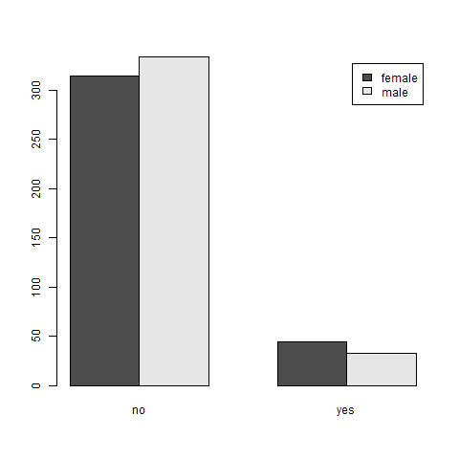

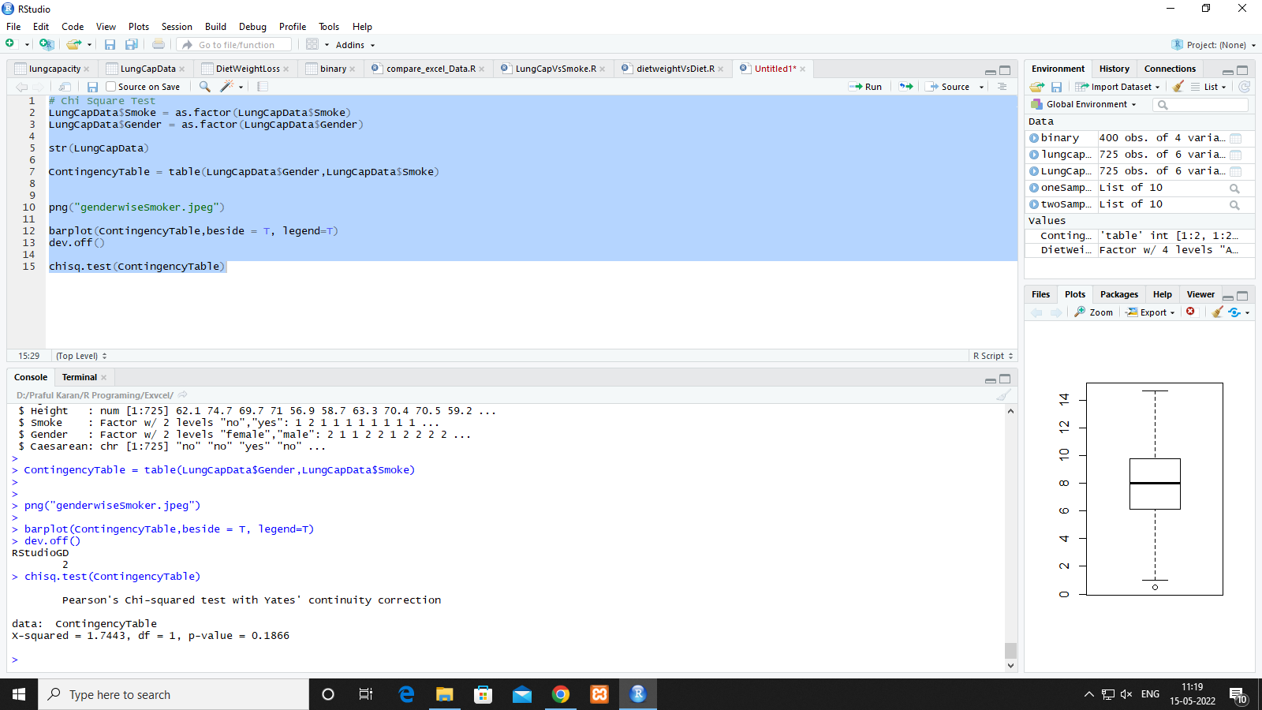

**# regression Models**

**# Linear regression**

# height in cm

Height = c(123,141,134,178,156,108,116,119,143,130) #x

# weight in KG

weight = c(62,85,56,21,47,17,76,92,62,58) #y

lRegModel = lm(weight~Height)

#plot the data on scatterplot

png("Linear regression scatterplot.jpeg")

plot(weight,Height,col="red",xlab="weight",ylab = "height")

abline(lm(Height~weight))

dev.off()

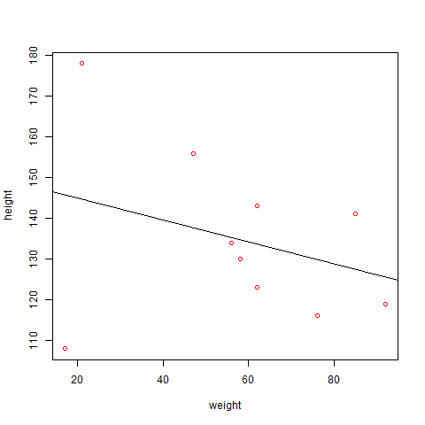

**Predict**

z = data.frame(Height=165)

predict(lRegModel,z)

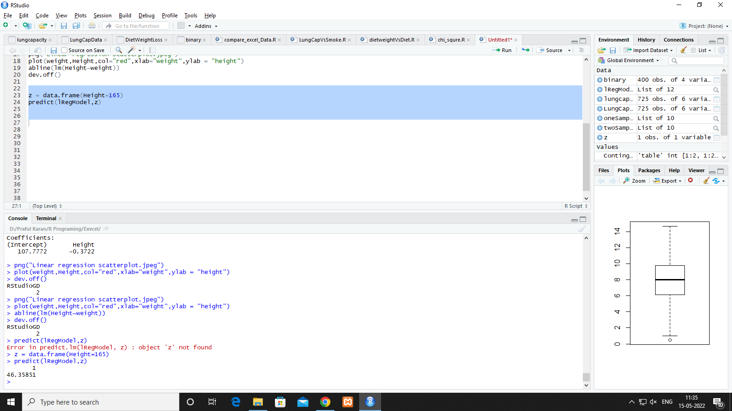

LungCapData

#plot the data on scatterplot

png("linear regression scatterplot Of LungCapData.jpeg")

plot(LungCapData$LungCap,LungCapData$Age,col="red",xlab="lungCap",ylab="age")

abline(lm(LungCapData$Age~LungCapData$LungCap))

dev.off()

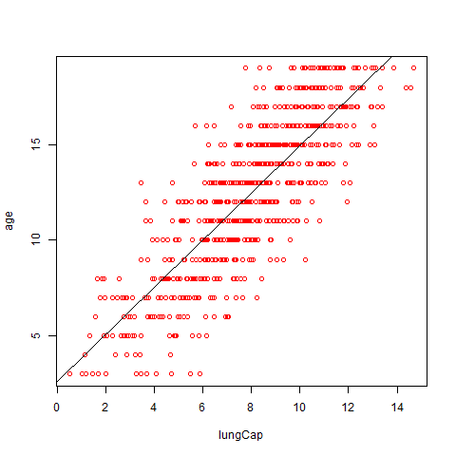

**# multiple linear regression**

attach(mtcars)

str(mtcars)

mlr=lm(mtcars$mpg~mtcars$disp+mtcars$wt)

summary(mlr)

z=data.frame(310,4.2,150)

predict(mlr,z)

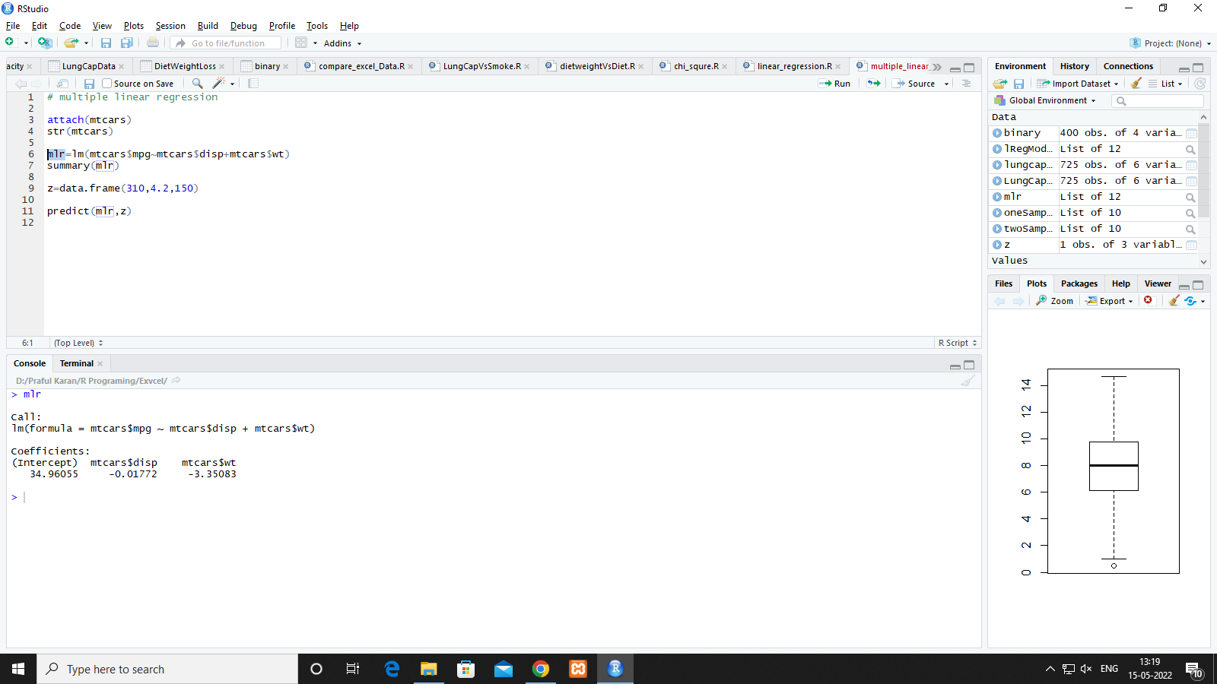

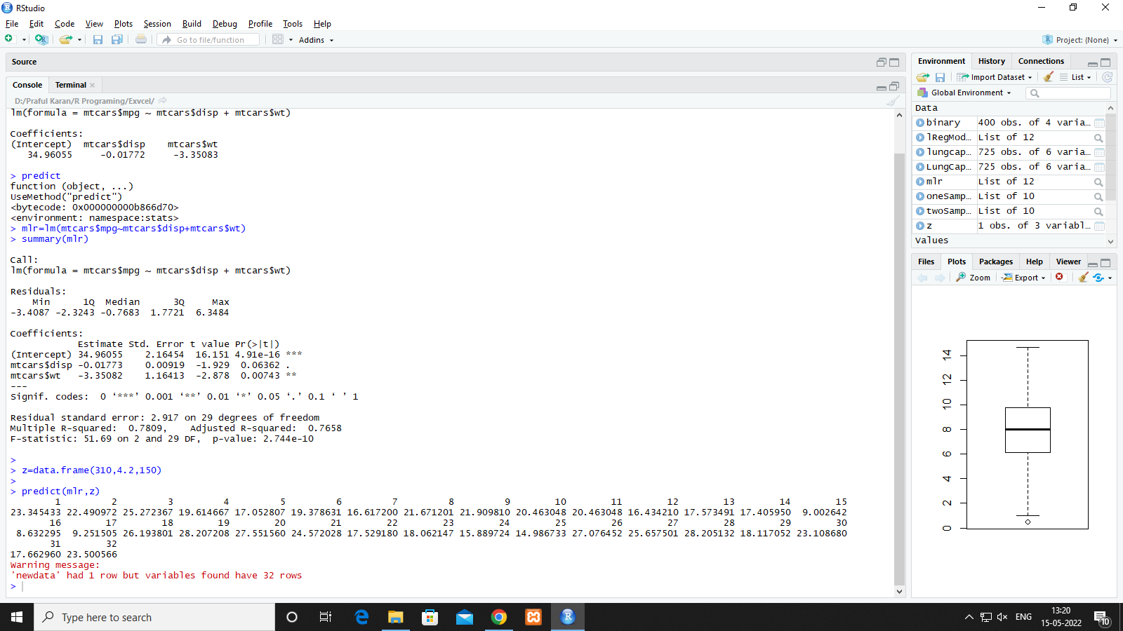

**# Time Series Analysis**

str(AirPassengers)

AP = AirPassengers

str(AP)

# freq = 12 because data collected for every month for every year starting from 1949 jan

ts(AP,frequency = 12, start = c(1949,1))

png("timeseriesPlot.jpeg")

plot(AP,ylab="No of tickets Booked")

dev.off()

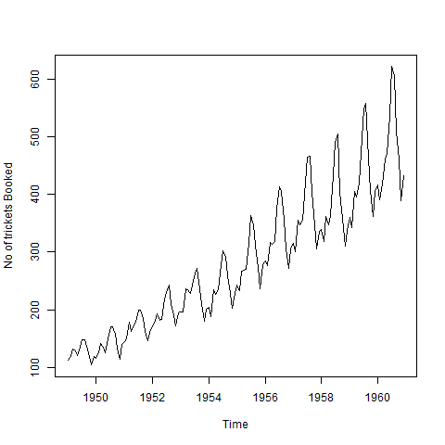

**#decomposition of data**

decomAP = log(AP)

png("timeseriesPlotAPValues.jpeg")

plot(decomAP,ylab="No of tickets Booked")

dev.off()

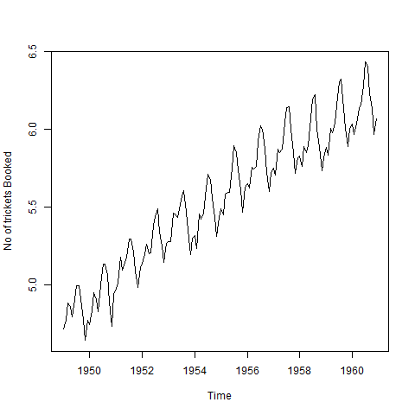

decomAP1 = decompose(AP)

png("Season&TreandInAPValues.jpeg")

plot(decomAP1,ylab="Seasonally")

dev.off()

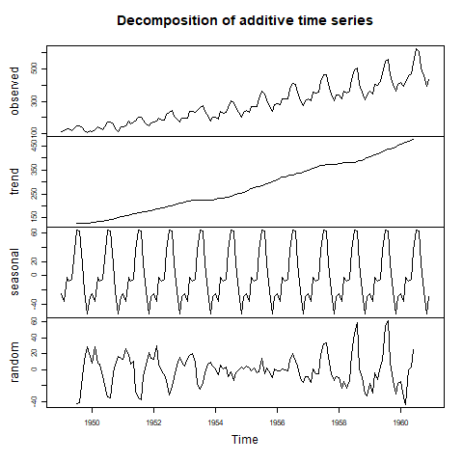

decomAP2 = decompose(AP)

attributes(decomAP2)

png("Season&TreandInAPValues1.jpeg")

plot(decomAP1,ylab="Seasonally",xlab="months",type="b",col="blue")

plot(decomAP2)

dev.off()